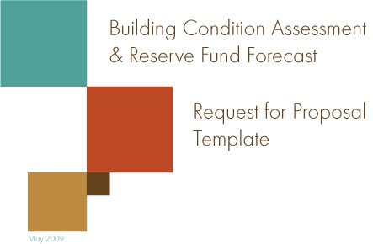

Foreword

Increasingly, the management of assets in public and broader public sectors is gaining greater and greater attention. This is due, in part, to the need to reduce escalating cost-pressures on all fronts - as well as to address the need for sustainability and energy conservation, and protect public investments in capital assets. There is also a strong commitment to ensure social housing tenants/members have safe and healthy built environments – with standards supporting a quality of life similar to the broader society.

The Asset Management Centre (AMC) will be providing the tools, resources and consistent standards necessary for housing providers and municipal service managers to address their capital repair needs. This RFP is one of many tools that will be available through AMC.

Acknowledgements

Sector partners on the AMC Steering Committee and the AMC technical sub-committee have made valuable contributions to this template and encourage the development and use of these standard materials sector-wide.

Special thanks go to SHSC and SHSC Financial Inc. for providing the templates for the AMC to modify according to input from the many housing provider and service manager volunteers. Thanks go out to the following service managers and housing providers who provided insightful comments and feedback on these materials:

- Deb Firmin, Niagara Regional Housing
- Alain Lacelle, The United Counties of Prescott and Russell
- Debbie Mills, Algoma District Social Services Administration Board
- Service managers and housing providers who worked with the technical committee on reviewing these materials.
Copyright

Originally created by the Social Housing Services Corporation Financial Inc. (SHSCFI)

Modified by the Asset Management Centre. (AMC) Copyright © 2008-2009 Asset Management Centre All rights reserved.

Table of Contents
Introduction 2
What is Asset Management? 3
Why is Energy Consumption Reduction So Important? 4
BCA and Reserve Fund Forecast RFP Templates 5
Getting Started 4
Building Condition Assessment and Reserve Fund Forecast Request for Proposal (RFP) 5
1. Call for Bids 5
2. The Property 5
3. Qualification of Bidders 5
4. Compliance with Applicable Laws 5
5. Notes on Standard of Replacement 5
6. Housing Provider 6
7. Scope of Work: Building Condition Assessment (BCA) 7
7.1 Assessment of Property 7
7.2 Visual Examination 7
7.3 Arranging for Entry 7
7.4 Handling Non-Compliance 7
7.5 Designated Substances 8
8. Recommended Building Condition and Energy Improvements 8
9. Deliverables 8
9.1 Contents of Building Condition Assessment 8
9. 2 Format of Building Condition Assessment 9
10. Housing Provider Representative 9
11. Process for work on Building Condition Assessment 9
11.1 Role of Housing Provider 9
11.2 Role of Consultant 10
12. Scope of Work: Reserve Fund Forecast 10
12.1 Generating the Reserve Fund Forecast 10
12.2 Data Gathering 10
12.3 Reserve Fund Forecast Report 11
12.4 Housing Provider Representative 11
12.5 Process for Work on Reserve Fund Forecast 11
13. Confidentiality 11
14. Bid Submission Requirements, Selection and Schedule 12
15. Evaluation Criteria 12
15.1 Contract Award and Execution 13

List of Appendix

Appendix A - Description of Properties to be Reviewed
Appendix B - Sample Capital Items List
Appendix C - AMC Capital Reserve Forecasting Software
Appendix D - Qualifications, Liability, Insurance and Conflict of Interest Provisions
Appendix E - Social Housing Reform Act, 2000
Appendix F - Form of Bid
Appendix G - Reference Form
Appendix H - Agreement

Introduction

In Ontario, the social housing portfolio has an approximate value of $40 billion. In recent years there has not been a sector-wide strategy to manage this valuable capital asset. In acknowledgement of this need, the Ministry of Municipal Affairs and Housing (MMAH) provided seed funding of $100,000 in early 2007 to establish an Asset Management Group (AMG). The role of the AMG was to bring together stakeholders to hire consultants, cover travel expenses, and identify and meet key deliverables. The Social Housing Services Corporation (SHSC) provided an additional $150,000 in funding as well as in-kind contributions, and acts as the coordinating body. The Ontario Non-Profit Housing Association (ONPHA) and the Co-operative Housing Federation of Canada (CHFC) have each provided $20,000 and additional in-kind contributions. The City of Toronto has also contributed in-kind, including educational materials on preventive maintenance. It is expected that other partners will make contributions over time.

As a result of the sector’s efforts, in March 2008, the province announced $100M in funding for the 47 municipal service managers to use towards the sector in areas of emergency repairs, health and safety or energy efficiency improvements: a loan program of $500 million for housing providers, and $1 million for the establishment of an Asset Management Centre (AMC).

One of the strengths of the Asset Management Centre is that it truly represents all organizations within the sector. Currently, the Asset Management Centre Steering Committee includes representatives from the following organizations:

- Service Manager Network (the Network)
- Ontario Non-Profit Housing Association (ONPHA)
- Cooperative Housing Federation – Ontario Region (CHF-Ontario)
- Social Housing Services Corporation (SHSC)
- SHSC Financial Inc. (SHSCFI)
- Ministry of Municipal Affairs and Housing (MMAH)
- Local Housing Corporations (LHCs)
- Canada Mortgage and Housing Corporation (CMHC)
- The Agency for Cooperative Housing (the Agency)

The broad mandate of the AMC is to coordinate the efforts within the sector to set standards and develop resources for asset management. This mandate spans from preventive maintenance through to the creation of a capital plan, with the goal of creating a sound asset management framework for social housing. This includes identifying opportunities to plan and manage capital expenditures.

The AMC will continue to function under the accountability framework of SHSC until firmly established and self-sustaining. It will continue to embrace principles of non-duplication, consensus building, openness and information-sharing, building on their efforts to increase capacity within the sector. The goals of the AMC are as follows:
- Create a sound social housing asset management framework that is streamlined and has consistent asset management standards endorsed by members of the AMC
- Identify opportunities and approaches to plan and manage capital expenditures
- Address a broad spectrum of asset management issues from preventive maintenance to the creation of capital plans
- Develop asset management capacity and resources through training and identification or development of good/best practices
- Assemble and maintain critical sector-wide information to support financial and business decision-making and planning on a province-wide basis

As a result of the sector’s efforts, in March 2008, the Province announced $100M in funding for the 47 municipal service managers to use towards the sector in areas of emergency repairs, health and safety or energy efficiency improvements: a loan program of $500 million for housing providers, and $1 million for the establishment of an asset management centre of excellence.

BCA and Reserve Fund Forecast RFP Templates

In keeping with the goals of the AMC, this template has been endorsed by its membership and is a tool to be used by the sector to begin to develop and support standard practices. Your feedback and comments are greatly appreciated. Send comments by email to the AMC c/o SHSC at feedback@shscorp.ca.

The AMC intends to provide the tools, resources and consistent standards necessary for housing providers and municipal service managers to address their capital repair needs, and ensure that these public assets are well-managed for both present and future generations.

The AMC has published this request for proposal (RFP) template and the companion AMC Capital Reserve Forecasting Software. Together, these tools are intended to create a standard approach for service managers and housing providers to use when purchasing technical expertise and beginning the important process of developing plans to better manage assets over the longer term. In recognition of the increasing focus on efforts about the benefits of reducing the energy footprint by governments, corporations, and citizens, the template also contains an energy audit component.

This Request for a Building Condition Assessment Template is for your use. This template serves as a guide for hiring the right consultant for a comprehensive assessment of the building conditions and to identify opportunities for energy savings. You should end up with a comprehensive, living document that is representative of the current status of your capital assets and energy usage. This knowledge will help you make sound capital repair, replacement, energy and financial forecasting plans and decisions. You will be strategically positioned to provide accurate and timely forecasts, plans and reports to your board or council on an on-going basis. You can also practically plan how to manage and possibly extend the life cycle of capital assets and achieve energy conservation and financial efficiencies.
The companion AMC Capital Reserve Forecasting Software has the capacity to allow housing providers and service managers to share information if so desired. It also has standard reporting features to facilitate reports to boards and municipal councils.

Note: For best results, you are strongly encouraged to use the companion Capital Reserve Forecasting Software that has been developed to support these templates. Please contact the AMC at 416-594-9325 for further information, or go to the website at www.shscorp.ca. To ensure we continue to meet your needs, it is anticipated that periodic updates of this software will be available based on user feedback.

What is Asset Management?

Asset management is the range of activities, including capital planning and expenditures, undertaken to ensure that housing stock (asset) is maintained in good repair, meets health, safety and access standards; and, is energy-efficient and addresses the needs of the community. Sound asset management extends the life cycle of many building components, reduces operating costs and provides a safer environment. Asset management also supports sound financial planning.

Sound asset management depends on tools such as:
- Building condition assessments;
- Energy audits;
- Preventive maintenance plans;
- Capital management/reserve plans; and
- Financial, legal and human resources for effective planning and implementation.

Why is Energy Consumption Reduction So Important?

Social housing providers in Ontario spend over $400 million a year on energy and water – their most volatile operating costs. Soaring energy costs, combined with inefficient buildings, mean that social housing providers are unable to address building repairs. But energy prices also affect families directly. Many housing residents pay their utilities themselves and energy poverty of low-income Ontario families continues to rise.

The need to reduce energy consumption also goes beyond cost. Experts believe there is a strong link between energy consumption, the creation of greenhouse gases and climate change. And climate change affects all of us.

Getting Started

The following template has been designed so that you can copy it on to a Word document and complete it according to your own needs. If you have any questions, please contact feedback@shscorp.ca

BCA and Reserve Fund Forecast Request for Proposal (RFP)

Call for Bids

[Insert name of Non-Profit Housing Corporation / Housing Co-operative and/or the Municipal Service Manager] is inviting bids from qualified consultants for a capital plan of its property [or portfolio], including a Building Condition Assessment and a Reserve Fund Forecast. The detailed Scope of Work is set out in sections 7, 8 and 9.

The Property [* Building/Portfolio]

[Insert the name of Housing Provider] is a [*] unit residential housing co-operative / non-profit housing corporation located in [insert municipality].

Note: [* Building/Portfolio] A detailed description of the property/properties to be included in the work is included in Description of Properties to be Reviewed Appendix A

Qualifications of Bidders

Bidders submitting a proposal must:

- Be qualified according to the requirements set out in Ontario Condominium Act Regulation 48/01 Subsection 32 (1) (attached in its current form in Appendix D Qualifications, Liability, Insurance and Conflict of Interest Provisions).
- Be available to carry out the work within the timelines set out in this Call for Bids.
- Not be in a conflict of interest as defined in the Reg. 339/01 of the Social Housing Reform Act (see below).

Compliance with Applicable Laws

The selected consultant must comply with and perform all applicable obligations of all applicable laws of Ontario and Canada including the Ontario Occupational Health and Safety Act, the Ontario Workplace Safety and Insurance Act and other applicable labour laws, the Ontario Human Rights Code and the Pay Equity Act.

Notes on Standard of Replacement

Items are to be replaced to the same standard as the original item unless:

- A less expensive item is available that can perform to the same standard
- A cost-benefit analysis (including energy savings) shows that replacement to a higher standard would be cost-effective
- A higher standard is required because of changes to the Ontario Building Code or other applicable legislation
- An item of the original standard is no longer available.

Energy efficiency, reduced energy use, and reduced water use are prime considerations. The consultant will recommend and estimate the replacement cost of capital items that consume or influence the consumption of energy and water. Recommendations and estimates will be based on current best available standards (e.g., ENERGY-STAR® )

Housing Provider Representative

[Insert name of Housing Provider] has appointed a representative who is the sole contact for the consultant selection process. All questions and requests for information by potential bidders during the preparation of their bid must be directed to the Housing Provider Representative in writing. No other person is authorized to give information.

The Housing Provider Representative is [*]

Scope of Work: Building Condition Assessment (BCA)

The consultant shall conduct a review of the [*building/ portfolio] in order to assess the current condition of capital items, and to identify the year and ongoing cycle of their replacement. The review will include the need for repair and rehabilitation of the building’s systems and components. The final report to [Insert name of Housing Provider] will provide recommendations for a capital plan that combines traditional capital replacement and repair recommendations and cost estimates (both capital and operational).

The recommended capital plan will be used to forecast the capital reserves, in place and required, as listed in Generating the Reserve Fund Forecast below.

Where required, the final report package must use the AMC Capital Reserve Forecasting Software and AMC-GLOBE Energy Audit Software.

7.1 Assessment of Property

The consultant’s assessment of the property will include a review of the following documents and information, if available:

- All architectural, structural and mechanical and electrical drawings and specifications
- All existing warranties, guarantees and service contracts
- Information on replacement cycles for appliances, flooring and other in-unit items
- Records of capital repairs or replacements
- Maintenance and inspections records and schedules
- Records of capital items added since original construction
- Any previous building studies and technical reports such as BCA or energy audit or assessments
- Any compliance orders
- Any current contractors’ quotations for capital repairs or replacements
- Records of any planned capital repairs or replacement
- Any other information on known property problems
- Utility expense reports and/or bills
- Environmental audits concerning designated substances

A pre-audit/assessment consultation would deal with these types of considerations at the beginning of the process and manage expectations from the outset. The consultant must meet with [insert name of Housing Provider and/or the Service Manager] for a pre-audit/assessment consultation. This meeting allows the consultant to outline to the housing provider and/or service manager the audit process and lets the housing provider and/or service manager give the consultant further instructions on the consultant’s approach to the audit. For example, [insert name of Housing Provider] might expect that certain things are included in the audit/assessment, such as recommendations for extending the life cycle of building components, possible renewable energy measures (solar walls, wind turbines, etc.), and whether the buildings could support such measures.

7.2 Visual Examination

The consultant must carry out a visual examination of the property’s capital items. The Sample Capital Items List, included 19, can be used as an initial point of reference. The consultant and the Housing Provider will jointly plan the site visits and other field work to efficiently meet the deliverables, including identifying the necessary work to complete the building condition assessment to industry standards. However, the consultant is responsible for creating a comprehensive inventory, appropriate for the property, of all the capital items, as-built and as-installed. The consultant should use the major categories in the Sample Capital Items List 19 to organize the inventory of capital items.

A review of the capital items on a sample basis is sufficient provided all categories of capital items are looked at and the sample size is large enough to give reasonable assurance of the validity of the observations. The consultant is required to examine a minimum of 10% of the total number of each type of housing unit. The specific units] to be examined will be selected by the consultant and Housing Provider jointly.
- Digital photographs shall be taken to document the conditions observed during the survey and to highlight deficiencies.

Note: If the property has elevators, include the following sentence:

“Elevator inspections must be carried out by a registered elevator inspection contractor.”
- The consultant shall prepare a visit survey for [tenants/members].

Note: You must make clear to the [tenant/member] that the visit survey is strictly for information gathering purposes by the consultant, to assist [insert name of Housing Provider/Service Manager] in capital asset planning. The visit is not intended to raise expectations about repair, maintenance or replacement of equipment, etc. However, the survey provides [tenants/members] with an opportunity to verify to the consultant any problems with the various building components in their units. This survey can be expanded for larger community groups and public consultation as part of the larger study and review as per direction from [insert name of Housing Provider/Service Manager].

7.3 Arranging for Entry

[Insert name of Housing Provider/Service Manager] is responsible for giving all notices necessary to arrange for entry to specific units. At least one week in advance of any entry, the consultant and the Housing Provider Representative must develop a schedule to allow time to give the adequate notice to affected [tenants/members]. The consultant’s representative(s) does not /do not enter any [*tenant’s/member’s] unit except in the company of the Housing Provider’s authorized personnel. All entries must take place on weekdays between the hours of 9:00 a.m. and 5:00 p.m., unless otherwise arranged. The consultant and its personnel must fully respect the rights and privacy of the [tenants/members].

7.4 Handling Non-Compliance

Where, in the course of inspection, the consultant finds evidence of non-compliance with current applicable laws and regulations such as the Ontario Building Code, Ontario Occupational Health and Safety Act and fire and safety legislation, the consultant will include this information in the Capital Plan report. The consultant, however, is not required to carry out a code compliance review.

Where, in the course of inspection or review of documents, the consultant finds evidence that
- the existing building component or equipment was not properly constructed, installed or commissioned,
- the existing materials used in a building component or equipment not properly specified for the application,
- the building component or equipment is not properly operated or maintained, and/or
- the intended design of a building space is not utilized to suit that application,

The consultant must include this information in the Capital Plan report.

7.5 Designated Substances

The consultant will carry out or sub-contract for an Environmental Audit on the presence of Designated Substances and will provide the appropriate recommendations concerning remediation or monitoring of any substances. The consultant will include this information in the Capital Plan report.

Recommended Building Condition and Energy Improvements

The recommendations for improvements within each system identifying energy savings and opportunities will include, but not be limited to, the following considerations:

- Identify equipment that should be replaced because it is at the end of its service life or there is a legislative requirement to do so: use a type and size of equipment/system that best meets current energy- and water-efficiency standards as well as other considerations; and, identify incremental costs between replacing mid-efficiency vs. high-efficiency equipment to maximize energy efficiency options.
- Identify equipment recommended for replacement due to potential energy savings although the components have not reached the end of their service life; include a cost benefit analysis including an energy savings analysis.
- Identify and explain recommended measures that involve multiple systems resulting in greater overall efficiencies, energy and cost savings, and resident comfort; indicate the year(s) that these combined projects appear in the recommended 30-year replacement plan.
- Include in the reporting package an explanation of any assumptions and methodology that the Housing Provider will need to know to assess the recommendations.

Deliverables

Contents of Building Condition Assessment

The report package to be submitted to the Housing Provider must include all of the following:
- Table of contents, including a list of appendices and supporting materials
- A description of the review undertaken, including its scope, the methodology used, the assumptions made, and the definitions of terms and standards used
- An executive summary of major findings and recommendations for each category of capital item:
  - Overview of existing equipment/systems (including photos where applicable)
  - Analysis of available options (where applicable)
  - Recommended measures (with justification)
- A separate chapter or section on capital issues, including (i) observations, if any, on the non-compliance of any item with applicable laws and regulations (see section.4), and (ii) a review of any major problem areas requiring further in-depth testing, including a description of the problems, the kind of testing needed, and an estimate of the cost
- A capital item data sheet for each capital item indicating
- what the capital item is and what it is made of,
- how many of each item there are,
- their physical condition,
- their actual or estimated age,
- their normal life span,
- when they will next need major repair or replacement (estimated remaining life), and
- the estimated cost of replacement in current dollars.
- A ranking of the replacement priority
- Preventive maintenance recommendations, if any, to make the items last longer
- A compact disc (CD) or equivalent storage medium designated by the Housing Provider containing all the digital photographs taken to document the conditions and deficiencies observed during the survey.
- A 30-year capital replacement plan: using the reporting format and spreadsheet software developed by the AMC -- the plan will include: a list of all items to be replaced, the number of each item, the time to the next replacement of each item, the cycle of replacement after that for a 30-year period following the date of the study, and the estimated cost of replacement in current dollars. Summary and roll-up sections will be included as directed by the Housing Provider.
- A prioritized remedial work plan that includes
- life/health and safety,
- building code compliance,
- structural,
- component failure, and
- the portion of the report and spreadsheet showing individual items and total estimated costs of replacement (in current dollars) will be provided in two different scenarios as follows: Capital Replacement Program; or Capital Replacement and Energy Program, identifying potential incentives/grants to offset potential capital costs.

Format of Building Condition Assessment

The consultant will give the Housing Provider
- two * hard copies of the reporting package outlined above, including the results of the Building Condition Assessment.
- one * electronic copy of all parts of the reporting package in a format specified by [insert name of Housing Provider], and
- one * copy of all digital photographs taken during the assignment.

Note: insert # of copies your organization requires.

Housing Provider Representative

[Insert name of Housing Provider] will appoint a representative who will be the principal liaison to the consultant throughout this section of the assignment, including during the Building Condition Assessment, and the preparation of the draft reports.

The [insert name of Housing Provider] Representative for this work is [*].

Process for Work on Building Condition Assessment

The Housing Provider works with the consultant to carry out the Building Condition Assessment as follows.

Role of Housing Provider
- [Insert name of Housing Provider] will make all the information set out in section 7.1 available to the consultant.
- The board of directors of [insert name of Housing Provider] will give the consultant comments on the draft Building Condition Assessment report.
- [Insert name of Housing Provider] can change the scope to reduce cost or for any other reason and negotiate lower costs with bidders. [Insert name of Housing Provider] is not required to negotiate lower costs with all bidders.
Note: Housing Providers and/or Service Managers must determine if this is allowed under their existing procurement guidelines.

Role of Consultant
- The consultant will develop a schedule for the site visits (one, or more if necessary) in collaboration with the Housing Provider Representative.
- The consultant carries out site visits. The Housing Provider Representative or designate will accompany the consultant during the site visits.
- The consultant prepares a list of as-built and as-installed capital items.
- The consultant presents their preliminary findings to [insert name of Housing Provider]’s board of directors and provides a draft copy of its reporting package, including a complete Building Condition Assessment report for the directors’ review.
- The consultant finalizes, submits and presents the final reporting package, including final Building Condition Assessment report to the board of directors.

Scope of Work: Reserve Fund Forecast

Generating the Reserve Fund Forecast

The Reserve Fund Forecast will be developed from the data in the Building Condition Assessment report and through further consultation with [insert the name of Housing Provider]. In the development of the Forecast, the consultant will use the Capital Reserve Forecasting Software developed by the AMC.

The [insert name of Housing Provider] will make the following information available to the consultant where available:
- The most recent audited financial statements (for specific audited financial information related to spending on operations, reserves and other relevant items)
- The latest financial statements and trial balance
- Records of any capital reserve spending that is not yet on the financial statements
- The previous Reserve Fund Forecast
- Information about current investments and the rate of investment return being earned
- Any future plans for investment of the capital reserves
- Any plans to make larger contributions to the capital reserve in the future

The consultant will meet with the Housing Provider Representative for the Reserve Fund Forecast to discuss the assumptions to be used for cost inflation of capital items and investment earnings on capital reserve balances.

12.2 Data Gathering

The Building Condition Assessment report will include a summary replacement and cost schedule presented using the electronic input template described above as applicable. The AMC Capital Reserve Forecasting Software will read the template to generate the replacement scheduling and costing information required for the forecast.

The consultant must enter the following information into the AMC Capital Forecasting Software:
- The opening balance of the capital reserve at the beginning of the survey period
- The program-mandated annual capital reserve fund contribution and index for annual increases
- Any additional annual fund contribution that [insert name of Housing Provider] plans to make
- Any lump sum transfers [insert name of Housing Provider] plans to make to the capital reserve, now or in the future
- The assumptions for inflation and capital reserve fund earnings supplied by [insert name of Housing Provider]
- Any grants or incentives that [insert name of Housing Provider] will receive or is planning to receive in the next 12 months

12.3 Reserve Fund Forecast Report

The consultant must provide [insert name of Housing Provider] with electronic and hard copy versions of the following forecast reports based on the two (2) capital replacement plans for the study period:
- Replacement schedule for capital work
- Detailed capital reserve fund projection
- Overview of capital reserve fund projection

These reports are set out in the reserve fund forecast based on the financial data supplied by the Housing Provider but before the addition of any supplementary contributions that may be required.

12.4 Housing Provider Representative

[Insert name of Housing Provider] will appoint a representative to be the principal liaison to the consultant in all matters concerning the Reserve Fund Forecast. This representative may, but need not be, the same person who performed this role at the Building Condition Assessment stage of the assignment.

The [insert name of Housing Provider] Representative for the Reserve Fund Forecast is [*].

12. 5 Process for Work on Reserve Fund Forecast

The consultant will meet with the [insert name of Housing Provider] Representative to
- explain the results of the forecast and the available options for adjusting the funding levels, as necessary, and/or the scheduling of replacements including the energy conservation initiatives, to cure any deficit in the fund, if possible, over the study period; and
- adjust the assumptions and planned contributions in the forecast to provide alternative scenarios to [insert name of Housing Provider] to reduce a fund deficit. Options could include: increased annual contributions (flat rate or indexed) and lump-sum contributions (single-year or multi-year).

The consultant will confirm [insert name of Housing Provider]’s preferred scenario for adjusting the capital reserve. The consultant will then provide a revised and final version of the forecast reports set out above in PDF format, and a schedule of the supplementary contributions required to adjust the forecast according to [insert name of Housing Provider]’s instructions. This will be the consultant’s final Reserve Fund Forecast report. The consultant will also provide a copy of the completed forecasting software for [insert name of Housing Provider] to use in future to update the forecast for management purposes.

The consultant will present the final Reserve Fund Forecast report to the board of directors.

Confidentiality

All information concerning [insert name of Housing Provider] gathered by potential bidders during the Call for Bids process is confidential and remains the property of [insert name of Housing Provider].

Bid Submission Requirements, Selection and Schedule

Bidders will be invited by [insert name of Housing Provider] or [Service Manager] to undertake a preliminary site visit before submitting their bid.

Note: Such a visit may be made mandatory as part of the bid process.

Before submitting their bid, bidders may also ask to review the electronic input templates to be used in preparing the Building Condition Assessment and the Reserve Fund Forecasting software.

All bids must include the standard Form of Bid (attached as Appendix F – Form of Bid ) duly completed and signed, and accompanied by

- an executive summary,
- general information about the bidder,
- a profile and qualifications of the bidder (including any sub-consultants),
- the name of the principal person who would have responsibility for the project and of the individuals who would carry out the work, no substitutions of sub-consultants without the written consent of the Housing Provider
- a proposed methodology for conducting the assessment,
- a detailed work plan, and
- any additional information that would provide insight into the bidder’s qualifications.

Only bids received by the closing [insert date/time] will be considered by [insert name of Housing Provider]. [Insert name of Housing Provider] will only evaluate complete bids. (see section 16 for evaluation criteria). The selected consultant will be informed not later than [*] after the closing of the Call for Bids. All other bidders will be informed, in writing, of the selection result.

Submitted bids must be irrevocable for 60 days following the proposal deadline.

The lowest, or any, bid need not be accepted by the Housing Provider.

[Insert name of Housing Provider] may reject any bid which fails to comply with any of the requirements of this Call for Bids. [Insert name of Housing Provider] may, in its absolute discretion, waive any deficiency, irregularity or informality in any bid or any breach of the requirements of this Call for Bids.

Evaluation Criteria

All submissions will be reviewed by your Evaluation Committee and will be scored using the criteria specified below. At the conclusion of this review, one or more candidates will be chosen to proceed to the final selection process. The preferred successful candidate(s) identified through the final selection process may be recommended to the Board by the Evaluation Committee as the consultant to undertake the job.

EVALUATION GRID – Building Condition Assessment
Part 1 – Evaluation of Consultant’s Response to Mandatory Requirements
 | Weighting | Evaluation Criteria
1 | Yes/No | Proposal received on time with correct number of copies
2 | Yes/No | Selected by Evaluation Committee as successful respondent to EOI
3 | Yes/No | Form of Response submitted, information presented in order requested, all mandatory questions confirmed and signed by authorized representative
4 | Yes/No | Attended mandatory pre bid meeting /site visit
If all mandatory requirements are met, evaluation of submission is made.
Part 2 – Evaluation of Proposed Solution
 | Weighting | Evaluation Criteria
1 | 25% | Qualifications and experience
2 | 25% | Insert requirement
3 | 25% | Insert requirement
4 | 25% | Proposed fee
 | 100.00% | Phase II – Stage One – Total

The following is the schedule for the project:
Last date for questions from potential bidders | [enter date]
Call for BIDS closes and submissions due by [*] am/pm | [enter date]
Evaluation and selection of consultant(s) | [enter date]
Contract award and execution  Initial site visit meeting | [enter date]
Site visits complete | [enter date]
Draft Building Condition Assessment report presented to board of directors | [enter date]
Board of directors’ comments on draft Building Condition Assessment | [enter date]
Final Building Condition Assessment report presented to board of directors | [enter date]
Draft Reserve Fund Forecast report and options for adjusting presented by Housing Provider Representative | [enter date]
Final Reserve Fund Forecast report and copy of completed forecasting software presented to board of directors. | [enter date]

[Insert name of Housing Provider] will send the bidders written notice of any change to the deadline for submitting bids.

Contract Award and Execution

The selected consultant will enter into an agreement with [insert name of Housing Provider] in the form, shown in Appendix H – Agreement, within ten days of receiving notice that they have been awarded the contract.

The term of the agreement may be extended, if necessary, with the mutual consent of the consultant and [insert name of Housing Provider].

The consultant will maintain the same liability insurance as specified in Subsection 32(4) of Ontario Regulation 48/01 under the Condominium Act (attached in its current form in Appendix D Qualifications, Liability, Insurance and Conflict of Interest Provisions. The consultant will observe the requirements of Subsections 32(5) and (6) of that Regulation as if the work described in the Call for Bids were a reserve fund study under the Condominium Act. Prior to execution of the agreement the successful bidder will give [insert name of Housing Provider] a certificate of the policy of liability insurance. This policy must remain in place for the duration of the contract.

The consultant will at all times comply with the Ontario Workplace Safety and Insurance Act. The consultant will provide with each request for payment a Clearance Certificate issued by the Workplace Safety and Insurance Board waiving any claim against [insert name of Housing Provider].

Both during and following the term of the work, the selected consultant must indemnify and save harmless [insert name of Housing Provider] from all costs, losses, damages, judgments, claims, demands, suits, actions or other proceedings in any manner based upon, occasioned by or attributed to anything done or omitted from being done by the consultant in connection with this work.
- Description of Properties to be Reviewed

Address | Year  Built | Construction Type(1) | Building  Type (2) | Structure ⁽³⁾ | Funding Program ⁽⁴⁾ | # of Elevators | Type of Heating | # of Units | # of Floors | Parking Garage  (Y/N)
⁽¹⁾ New construction, rehabilitation, conversion ⁽²⁾ Apartments, townhouse; ⁽³⁾ Wood frame, concrete, etc.; ^{(4) Social} Housing Reform Act, Section 95, Section 61,

Building Type

In the following table, check off the description that most closely matches the building in question.

Low-rise apartment | 3 storeys or less with garage
 | 3 storeys or less without garage
High-rise apartment | >3 storeys with garage
 | >3 storeys without garage
Townhouse | with garage
 | without garage
Scattered unit(s) | semi-detached
 | Detached
 | Single
Mixed building types | i.e., townhouses and apartment, etc,
- Sample Capital Items List

The following must be used by the consultant as an initial point of reference in preparing the comprehensive list of capital items.

Site work | Mechanical Systems
Driveways  Driveway – paving stones  Driveway – asphalt  Driveway – concrete  Driveway – gravel  Parking lots  Parking lot – paving stones  Parking lot – asphalt  Parking lot – concrete  Parking lot – gravel  Sidewalks  Sidewalk – paving stones  Sidewalk – asphalt  Sidewalk – concrete  Sidewalk – gravel  Curbs  Fencing  Swimming pool  Playground – equipment  Retaining walls  Garbage area and structure  Handrails  Storage buildings  Maintenance buildings  Drainage away from building  Storm water drains  Catch basins  Storage tank pumps  General landscaping | Heating system – common areas  Heating system – units  Air make-up systems  A/C chiller systems  Exhaust systems – bathroom  Exhaust systems – kitchen  Exhaust systems – centralized  Well-water supply  Holding tank  Domestic water supply and distribution  Domestic water shut-off valves and mains  Domestic water – risers  Domestic water – units  Domestic water – hot water tanks  Supply – hot water heating system  Domestic water recirculating system  Domestic water treatment system  Fire hydrants  Fire alarm – sprinkler system  Fire department – connections and standpipes  Fire extinguishers  Fire hoses  Sanitary waste removal system  Septic system  Storm water including roof drains  Sump pumps  Garbage collection and compactor  Other: [specify]

Building Interior
Plumbing fixtures – common areas – toilets  Plumbing fixtures – common areas – sinks  Plumbing fixtures – common areas – vanities  Plumbing fixtures – common areas – faucets  Plumbing fixtures – common areas – bathroom accessories  Plumbing fixtures – service areas – sinks  Plumbing fixtures – service areas – faucets  Plumbing fixtures – units – sinks  Plumbing fixtures – units – toilets  Plumbing fixtures – units – faucets  Plumbing fixtures – units – vanity  Plumbing fixtures – units – tubs  Plumbing fixtures – units – tub surrounds  Plumbing fixtures – units – bathroom accessories | Ceilings – common areas  Ceilings – service areas  Ceilings – units  Walls – common areas  Walls – service areas  Walls – units  Floors – common areas  Floors – service areas  Floors – units  Stairs  Stairway handrails  Interior doors – common areas  Interior doors – service areas  Interior doors – units  Millwork - trim, base  Lighting fixtures – common areas  Lighting fixtures – service areas  Lighting fixtures – units  Plumbing fixtures – common areas  Plumbing fixtures – service areas  Plumbing fixtures – units  Tub, toilet, sink  Appliances – refrigerators  Appliances – stoves  Appliances – washers  Appliances – dryers  Appliances – other  Cabinetry  Countertops  Corridor handrails  Voice communication system enter-phone  Storage lockers

Building Exterior | Life Safety Systems | Parking Garages
Roofing systems  Roof anchors  Eavestroughs  Soffit and fascia  Caulking  Exterior walls  Canopies  Balcony decks  Balcony railings  Windows  Doors  Flashing  Mailboxes | Fire alarm – panel  Fire alarm system – heat detectors  Fire alarm system – smoke detectors  Smoke detectors  Fire alarm system – pull stations  Fire alarm system – bells, warning devices  Carbon monoxide detectors  Emergency generator  Emergency lighting  Door magnets  Fire alarm voice communication  Lobby annunciator panel  Exterior lighting system  Security door system  Security surveillance  Matv system  Fuel storage tanks  Other: [specify] | Garage ramp – enclosures  Garage ramp – entrance/exit  Garage ramp – interior  Garage slab – roof  Garage floors – suspended  Garage floors – slab on grade  Garage – walls  Garage – columns  Waterproofing – roof  Waterproofing –  Stairwell enclosures  Stairs  Drainage system trenches and drains  Lighting system  Ventilation system  Heating system – space heating  Heating system – ramp slab  Fire suppression – sprinklers  Fire extinguishers  Fire hoses  Security system  Overhead doors  Exterior doors  Interior doors  Interior service areas  Interior guardrails  Other: (as necessary)

Structure | Electrical Systems | Elevators
Columns  Parapets  Foundation walls  Shear walls  Floor slabs | Primary transformer  Building connections  Duct banks  Switch gear  Distribution system  Panels  Lights  Lines  Other: (as necessary) | Elevator cab  Elevator hoisting equipment  Elevator motor  Elevator electrical equipment  Elevator controller  Elevator cooling equipment  Elevator sump  Elevator pit walls  Electrical Systems  Distribution panel – main  Distribution panel – intermediate  Distribution panel – unit  Transformer

- Capital Reserve Forecasting Software

The following tables are samples of the templates included in the AMC Capital Reserve Forecasting Software Vs.

For more information please refer to the actual AMC Capital Reserve Forecasting Software

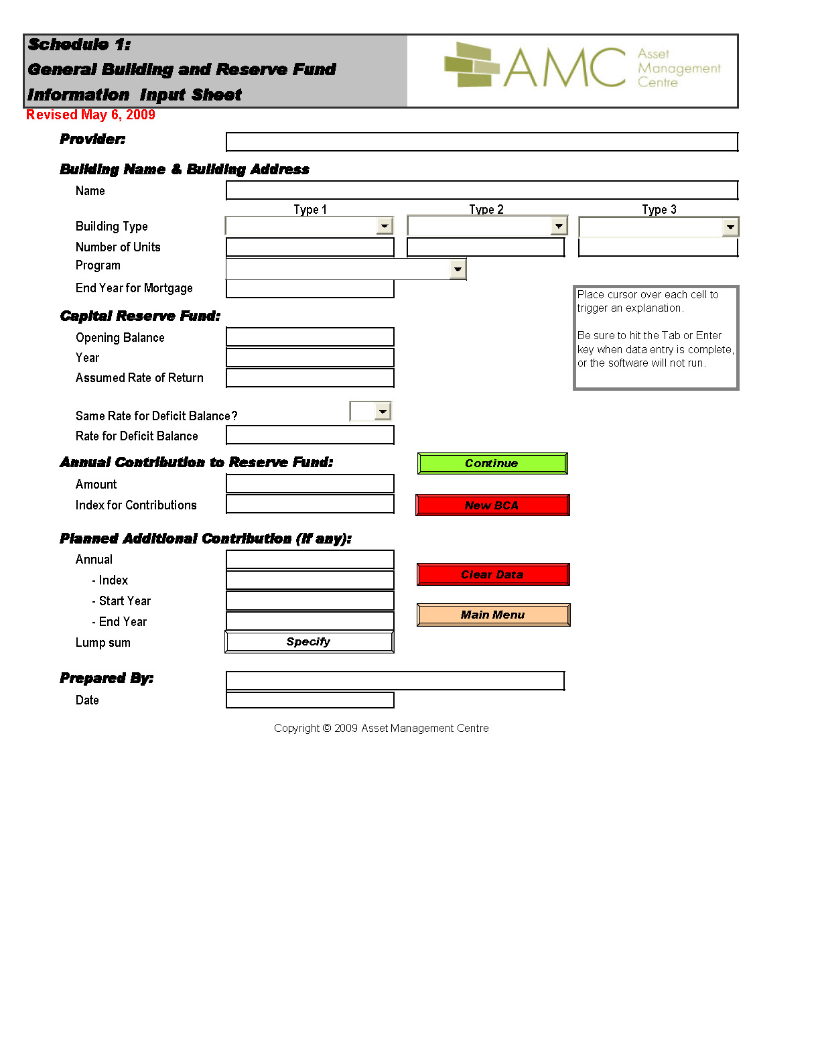
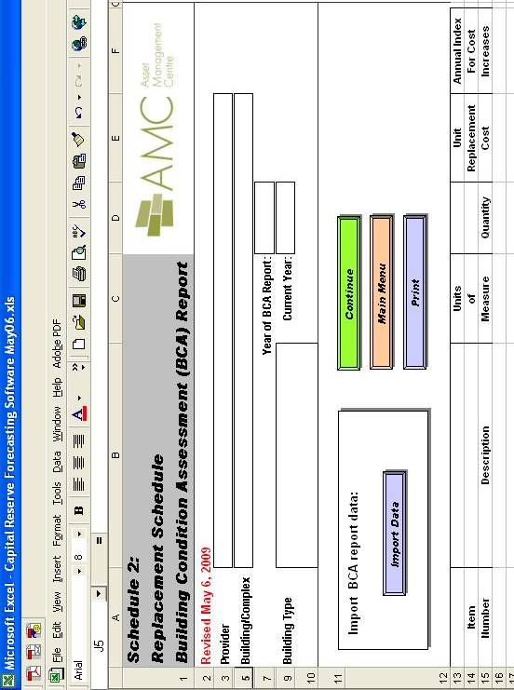

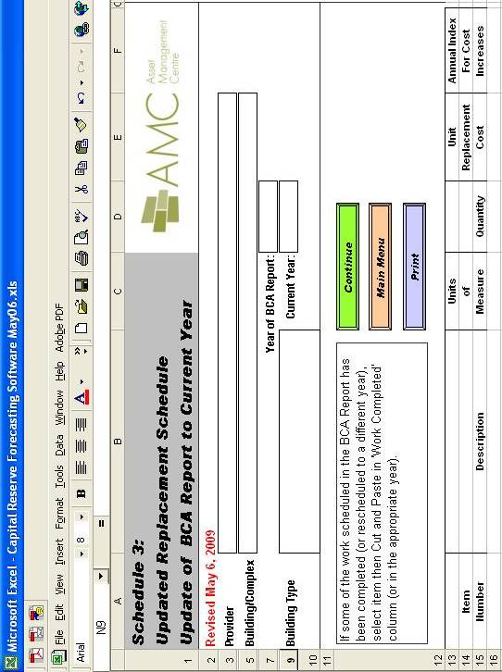

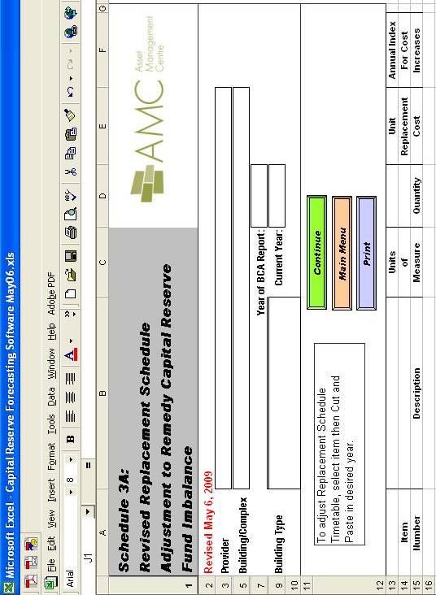

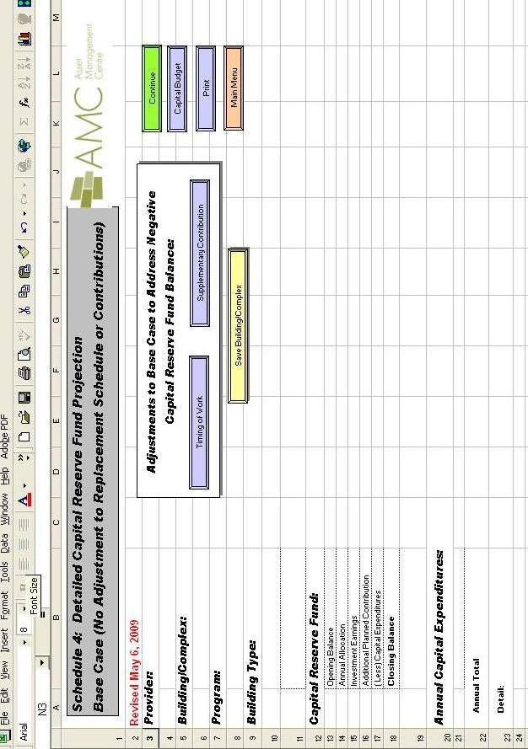

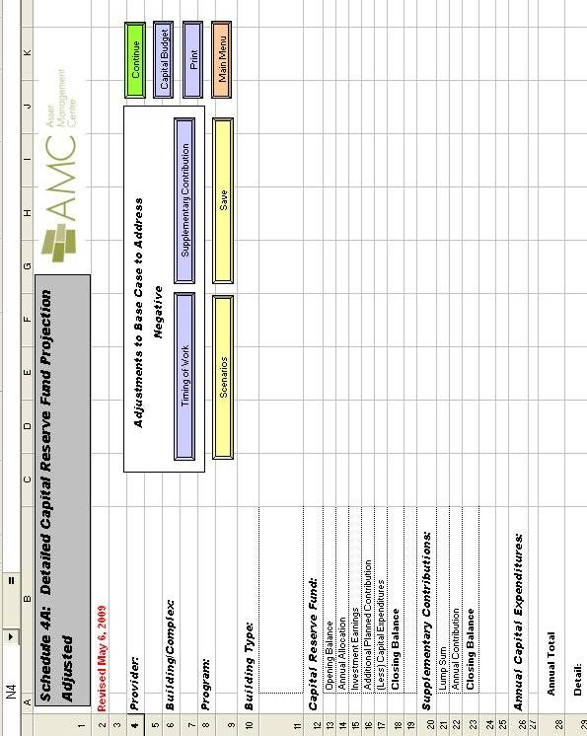
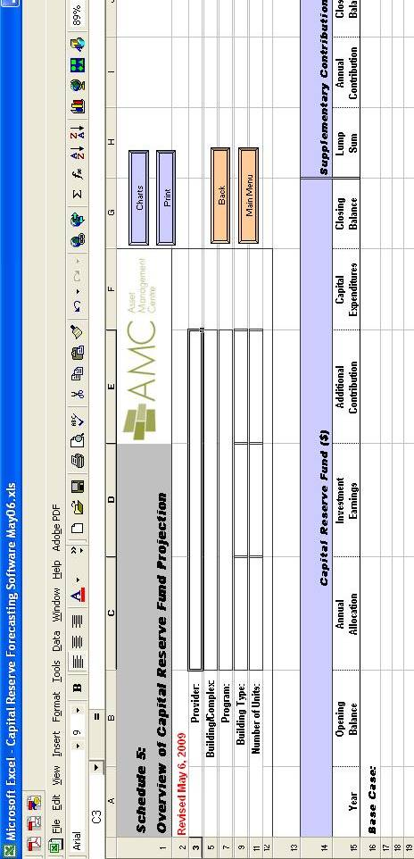
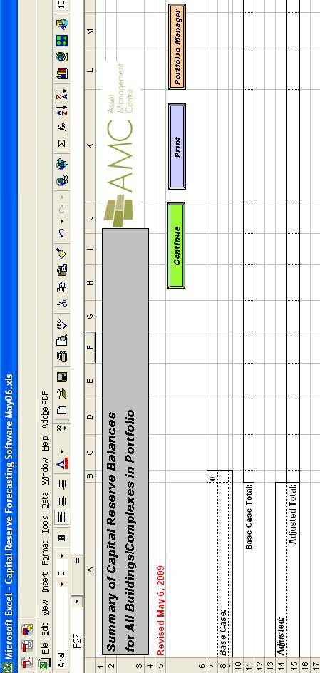

Appendix D Qualifications, Liability, Insurance and Conflict of Interest Provisions

Condominium Act Regulation 48/01 General

PART IV: RESERVE FUND STUDIES

Person Conducting Study
- [Qualifications]

32 (1) Subject to subsection (2), the following classes are prescribed as persons who may

conduct a reserve fund study:
- Members of the Appraisal Institute of Canada holding the designation of Accredited Appraiser Canadian Institute
- Persons who hold a certificate of practice within the meaning of the Architects Act
- Members of the Ontario Association of Certified Engineering Technicians and Technologists who are registered as certified engineering technologists under the Ontario Association of Certified Engineering Technicians and Technologists Act, 1998
- Members of the Real Estate Institute of Canada holding the designation of certified reserve planner
- Persons who hold a certificate of authorization within the meaning of the Professional Engineers Act
- Graduates of Ryerson Polytechnic University with a Bachelor of Technology (Architectural Science) – Building Science Option or Architecture Option
- Members of the Canadian Institute of Quantity Surveyors holding the designation of professional quantity surveyor
- Members of the Association of Architectural Technologists of Ontario holding the designation of architectural technologist, architecte-technologue or registered building technologist under the Association of Architectural Technologists of Ontario Act, 1996. O. Reg. 48/01, s. 32 (1)

2. [Liability Insurance]

32 (4) A person who conducts a reserve fund study shall be insured under a policy of liability insurance that includes

(a) coverage for liability for errors, omissions and negligent acts arising out of conducting or not conducting a reserve fund study, subject to the exclusions, conditions and terms that are consistent with normal insurance industry practice;

(b) a policy limit for each single claim of not less than $1 million per occurrence;

(c) an aggregate policy limit in the amount of not less than $2 million per year for all claims in the year or an automatic policy limit reinstatement feature; and

(d) a maximum deductible amount of $3,500 per occurrence. O. Reg. 48/01, s. 32 (4).

Appendix E – Social Housing Reform Act, 2000

Social Housing Reform Act, 2000 Regulation 339/01

PART II: CORPORATE GOVERNANCE

Conflict of interest
- This section applies to a housing provider in addition to the provisions of the Act listed in subsection 3 (1) to which The Housing Provider is subject.
- A conflict of interest exists if any of the following situations occur:
- The personal or business interests of a director, officer, agent or employee of a housing provider are in conflict with the interests of The Housing Provider.
- A personal gain, benefit, advantage or privilege is directly or indirectly given to or received by a director, officer, agent or employee of The Housing Provider or a person related to one of them as a result of a decision by The Housing Provider.
- A director, officer, agent or employee of The Housing Provider shall not enter into any situation, arrangement or agreement which results in a conflict of interest.
- Directors, officers, agents and employees of The Housing Provider must notify the chair of the board of directors of The Housing Provider of every potential or actual conflict of interest no later than the first meeting of the board after the director, officer, agent or employee becomes aware that he or she has entered into a situation, arrangement or agreement that results in or may result in a conflict of interest.
- The board of directors shall consider the notice given under subsection (4) no later than the second meeting of the board after the notice is given and consideration of the notice must be reflected in the minutes of the meeting.
- The chair of the board shall notify the Service Manager in writing of the receipt of every notice under subsection (4) and the board of directors shall resolve every conflict of interest or potential conflict of interest to the satisfaction of Service Manager.
- Despite subsection (3), a director, officer, agent or employee or a person related to one of them may directly or indirectly receive a gain, benefit, advantage, privilege or remuneration from The Housing Provider if all of the following conditions are satisfied:
- A notice of the conflict of interest or potential conflict of interest is given in accordance with subsection (4).
- Service Manager agrees that there is no reasonable alternative for The Housing Provider other than entering into the situation, arrangement or agreement that results in or may result in the conflict of interest.
- For the purposes of this section, a person related to a director, officer, agent or employee includes a parent, spouse, same-sex partner, child, household member, sibling, uncle, aunt, nephew, niece, mother-in-law, father-in-law sister-in-law, brother-in-law or grandparent, or a person with whom the director, officer, agent or employee has a business relationship.
- In this section,
- "child", in relation to an individual, means a child of the individual born within or outside marriage (unless that child has been adopted by one or more other individuals in Ontario or according to the law of another jurisdiction), a child adopted by the individual in Ontario or according to the law of another jurisdiction, and a child whom the individual has demonstrated a settled intention to treat as a child of his or her family, but does not include a child placed in the individual's home as a foster child for consideration by another person having lawful custody;
- "parent", in relation to an individual, means a natural parent of the individual (unless the individual has been adopted by one or more other persons in Ontario or according to the law of another jurisdiction), an adoptive parent of the individual who has adopted the individual in Ontario or according to the law of another jurisdiction, and a person who has demonstrated a settled intention to treat the individual as a child of his or her family, but does not include a person in whose home the individual has been placed as a foster child for consideration by another person having lawful custody;
- "same-sex partner", in relation to a person, means,
(a) an individual of the same sex as the person, if the individual and the person have together advised The Housing Provider that they are same-sex partners, or
(b) an individual of the same sex as the person who resides in the same dwelling place as the person, if the social and familial aspects of the relationship between the individual and the person amount to cohabitation and,

(i) the individual is providing financial support to the person,

(ii) the person is providing financial support to the individual, or

(iii) the individual and the person have a mutual agreement or arrangement regarding their financial affairs;
- "spouse", in relation to a person, means,
(a) an individual of the opposite sex to the person, if the individual and the person have together advised The Housing Provider that they are spouses, or
(b) an individual of the opposite sex to the person who is residing in the same dwelling place as the person, if the social and familial aspects of the relationship between the individual and the person amount to cohabitation and,

(i) the individual is providing financial support to the person,

(ii) the person is providing financial support to the individual, or

(iii) the individual and the person have a mutual agreement or arrangement regarding their financial affairs.

Replacement of Conflict of Interest Rules

The conflict of interest provisions set out in section 4 may be replaced for a housing provider by rules agreed to by The Housing Provider and Service Manager for all areas in which its housing projects are located, in accordance with subsection 93 (3) of the Act.

Appendix F – Form of Bid

Form of Bid

[the consultant’s registered legal business name and mailing address]

Phone: [telephone number]

Fax: [fax number]

Contact: [contact person]

Housing provider: [name of housing provider]

We hereby offer to perform the Building Condition Assessment, and the Reserve Fund Forecast as described in the Call for Bids issued by [insert name of Housing Provider] dated [enter date] as modified by the following addenda:
- List addenda or insert “None”

On the terms and conditions and within the timeframe, stated in the Call for Bids at the fixed price of [*] Dollars ($) this price includes Goods and Services Tax and all expenses and disbursements.
- We declare and agree to the following:
- we have carefully examined the Call for Bids, including any addenda
- we understand the work required under the Call for Bids
- we understand and agree to the terms and conditions included in the Call for Bids
- we enclose with this offer all items that are required to be submitted with this offer under the Calls for Bids
- this offer is irrevocable by us for a period of 30 days after the submission deadline stated in the Call for Bids.
- We authorize [insert name of Housing Provider] to perform reference checks using the references listed in the Reference Form.
- We confirm that we meet the qualifications for carrying out a Building Condition Assessment established in Ontario Condominium Act Regulation 48/01 subsection 32 (1).
- We confirm that we meet the qualifications for carrying out an Energy Audit, as specified by [insert name of Housing Provider] and this bid document.
- We confirm that we do not have any conflict of interest in connection with this bid as described in Sections 4 and 5 of Ontario Regulation 339/01 under the Ontario Social Housing Reform Act, 2000 (attached in its current form in Appendix E – Social Housing Reform Act, 2000). If any conflict of interest should subsequently arise, we will promptly report it under that section in the same manner as if we were an agent of [insert name of Housing Provider] and act on all reasonable directions of the Housing Provider.
- We agree to keep secret all information concerning [insert name of Housing Provider] in accordance with section 4 of the Call for Bids.
- We agree that, if our bid is accepted, we will execute an agreement with [insert name of Housing Provider in accordance with the Call for Bids.
- We agree, if our bid is accepted, to provide proof of insurance coverage as required by the Call for Bids prior to execution of the agreement.
- Accompanying this bid are the following:
- an executive summary
- general information about the bidder
- profile and qualifications of the bidder (including any sub-consultants)
- name of the principal person who would have responsibility for the project and of the individuals who would carry out the work
- proposed methodology for conducting the assessment

[*] INC.

}
} By: _________________________________
} [enter name]
} [enter title]
} have authority to bind the Corporation
Date: [enter date] }
}
} _________________________________
} [enter name]
} [enter title]
} have authority to bind the Corporation

Appendix G - Reference Form

Three clients for whom the consultant has provided similar services (Building Condition Assessments, Energy Audits, and Reserve Fund Forecasts) in the past three years are requested as references.

REFERENCE # 1

Client: Telephone:

Address:

Nature of Project

Nature of Project:

Date of Project: [insert date]

REFERENCE # 2

Client: Telephone:

Address:

Nature of Project:

Date of Project: [insert date]

REFERENCE # 3

Client: Telephone:

Address:

Nature of Project:

Date of Project: [insert date]

Appendix H – Agreement for BCA & RFF

Agreement for Building Condition Assessment and Reserve Fund Forecast

This agreement made on (enter date) _______________________________________

BETWEEN

[*Name of Housing Provider] _____________________________________________
(the client)

AND

[* name of the Consultant] ___________________________________________________
(the consultant)

- Acceptance of Bid
The [*name of Housing Provider] (The Client) accepts the [*name of Consultant] (the Consultant) bid dated [*enter date of Bid] to provide the Client with a Building Condition Assessment and a Reserve Fund Forecast for the Client’s property situated at [enter address(es)], subject to the following changes:
- [list changes or insert “none”]
The Consultant’s Bid and the Client’s Call for Bids are attached to this Agreement as Schedules 1 and 2 and form part of it.
The Consultant agrees to perform the obligations under this Agreement and agrees to perform them within the timelines stated in the Call for Bids.

- Fees
The Client agrees to pay the Consultant the sum of [*] Dollars ($CDN). This price includes Goods and Services Tax and all expenses and disbursements. One half of the fee will be paid within 30 days of submission by the Consultant to the Client of a satisfactory first draft of the Building Condition Assessment report together with the invoice. The balance will be paid within 30 days of the submission by the Consultant to the Client a satisfactory final Building Condition Assessment and Reserve Fund Forecast reports and a copy of the completed AMC Capital Reserve Forecasting Software.

- Client’s Representative(s)
The Client’s representative for the purpose of the Building Condition Assessment (BCA) will be [*enter name of provider’s representative].

The Client’s representative for the purpose of the Reserve Fund Forecast (RFF) will be [* enter name of the provider’s representative].

- Consultant’s Personnel
The persons named in the Consultants Bid as the persons who will have responsibility for the project and the individuals who will carry out the work may not be changed without the written consent of the Client.

- Relationship of the Parties
Nothing in this Agreement will create any partnership, joint venture, agency, trust or other relationship between the parties. It is agreed that their relations are entirely contractual as set out in this agreement. Neither of the parties has the authority to bind the other or to commit in any way, except as specifically stated in this Agreement.

- Entire Agreement
This Agreement and the documentation and materials referred to in this Agreement contain the entire agreement between the parties. No change or waiver under this Agreement will be binding unless it is in writing and signed by the party that is bound by it.

- Assignment
This Agreement may not be assigned or subcontracted by either party without the prior written consent of the other.

- Confidentiality
The Consultant will, both during the term of this Agreement and after completion or termination of this Agreement, keep confidential any information about the Client, the Client’s property, activities, and business and the Client’s residents and their units, which the Consultant may learn about during the term of this Agreement. All such information will remain the property of the Client or the Client’s residents.

- Termination
If either party is in default under this agreement, the other may give them one week’s written notice of default. Unless the default is cured within the one-week period, the party that gave the default notice, in addition to any other remedy it may have, may terminate the Agreement by a written termination notice on delivery of the termination notice.

- Consultant’s Insurance
Prior to signing this Agreement, the Consultant will provide the Client with a certificate of liability insurance required under the Call for Bids.

- Signing this Agreement
This Agreement may be signed by facsimile. Each party can sign a separate copy of this Agreement.

SIGNED:
CONSULTANT } [*] Inc.

} By: ____________________________________
} (enter name)
} (enter title)
} I have the authority to bind the Corporation

} By: ____________________________________
} (enter name)
} (enter title)
} I have the authority to bind the Corporation

Date: (enter date) __________________________

CLIENT } [*enter name of housing provider]
}
} By: ___________________________________
} (enter name)
} (enter title)
} I have the authority to bind the Corporation

} By: ____________________________________
} (enter name)
} (enter title)
} I have the authority to bind the Corporation

Date: (enter date) _________________________

