CFDI NEWS 
www.cfdi.ca email: communityfirst@cfdi.ca DECEMBER 2004

SEASON’S GREETINGS!

This is the last edition of the CFDI Newsletter for 2004. It is difficult to grasp that a whole year has passed and another is about to begin. Normally, we associate the year with changes that affect us personally, but if we look around, changes were everywhere. We got a new mayor, a new premier and a new prime minister. Closer to home we got a new company, a new office and lots of new staff. Change often induces introspection and the year end is a good time to evaluate and access change to aid us in gaining a proper perspective on our work, our company and our future. The future is bright for CFDI and Comfield Management Services and hopefully, you will join in the enthusiasm and challenges of 2005 and continue to share in a company where everyone’s door is always open.

President’s Note . . .
I know we are all busy trying to tie up loose ends before the holiday and wondering if it even makes sense to try to do two weeks work in one. But it does and it will. I know I am looking forward to four days of uninterrupted peace (fingers crossed), even some joy. It will be a time to reflect on the many accomplishments during the year and maybe even to start thinking about what lies ahead. I trust you will enjoy your time with family and friends and savour the much needed fun and relaxation that we have all been looking forward to.

It is quite an amazing time of the year when usually reserved individuals lavishly decorate their homes, dress up in funny red suits and try not to eat and/or drink too much. Enjoy the Wonder of the Season!

On behalf of Cristina and Eddie, I would like to wish you and your family a Very Happy Holiday Season & a Happy, Healthy and Prosperous New Year!

GIFTS
by Miranda Pinto
One of the things I love about the Christmas season is the celebration of my large extended family. We have never been much into the commercialization of Christmas, however, it is the time of year when we are reminded of and celebrate the “gifts” of each other. We eat, laugh, talk, share stories and tease one another. One image stands out to me– a 22 year old at a restaurant table with a 12 year old cousin (both oblivious to the other 30 at the tables) intently listening to the younger one’s tales of woe. It ends with a few words of advice and encouragement to “keep trying” along with a reminder to call if the cousin needs to talk. This relationship began 10 years earlier.
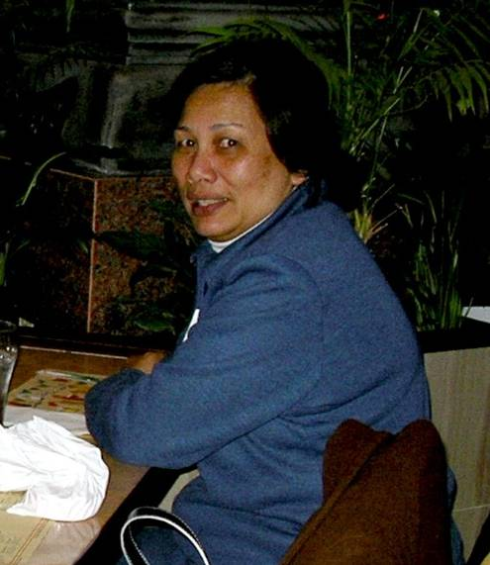
When I first came into contact with Community First a few years ago my professional background in community development made me question whether the company understood the value system implied in its name. Over the past year I have come to see that this is a small company with a very big name to live up to as the name is a statement of values. While the company is expanding quickly and experiencing growing pains, it has staff with many different gifts to offer. Just like the cousins mentioned above, we have the gift of trust to offer one another. Having the Community First name as a part of our identity, we are continually reminded of our gift of listening when a resident comes to us whether we are in administration (as most are) or community development. The gifts we share with each other and with the people we serve will also translate into the gift of respect that we receive.
Happy Holidays Everyone!
Memories from the Christmas Dinner
by Aleks Milenkovic
In keeping with the multicultural flavor of the CFDI Annual Christmas Party a truly exotic location was chosen this year. Memories of Japan – a refreshingly authentic Sushi & Japanese cuisine restaurant located in the central Don Mills & Eglinton area was our host this year.
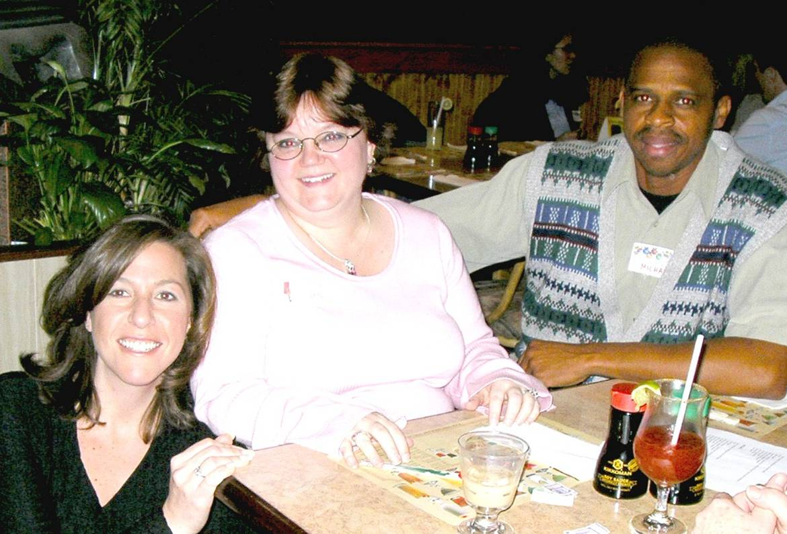
Some noted that the November date of the event seemed odd for the Yule occasion. Luckily, the polite accommodating restaurant staff did their best to convey the spirit with Christmas decorations. The spacious area reserved for our employees quickly filled up and additional tables had to be arranged to accommodate all. The logic of the scheduling became apparent as we all had a chance to admire our company’s numbers which were not held back by the December frenzy.
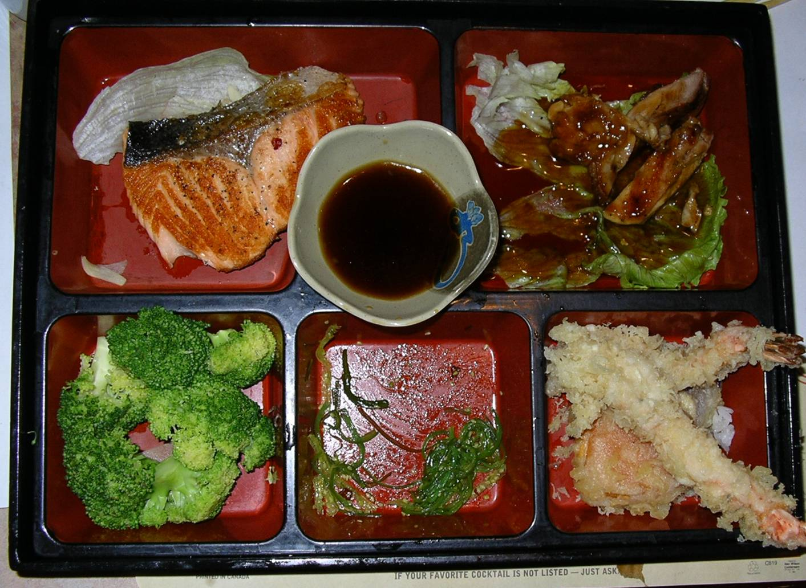
It was a pleasure to see some of our coworkers’ hidden traits so well illuminated by their better halves.
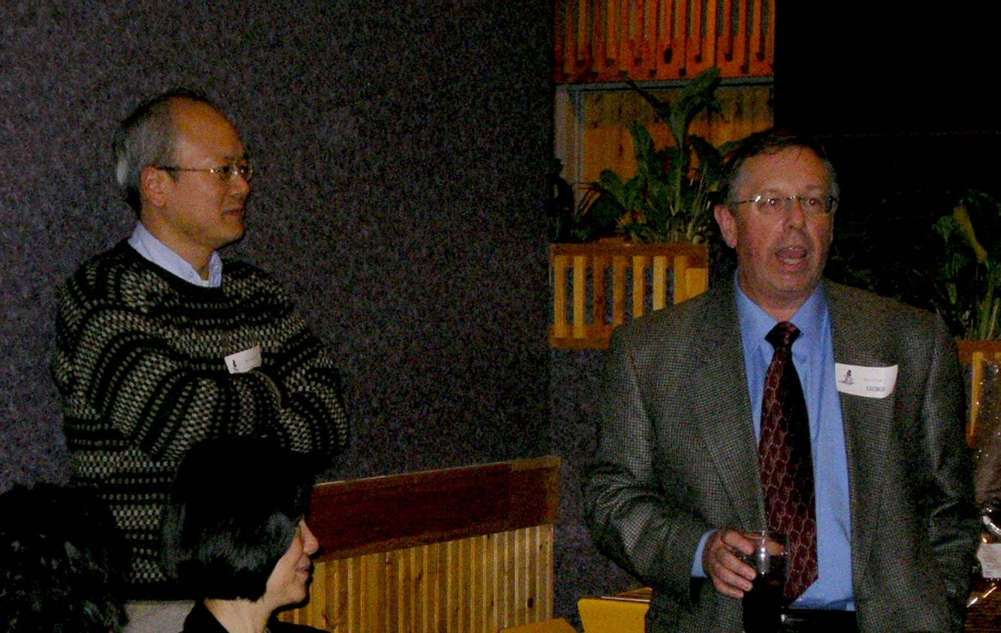
The initial fear of going hungry with a semi-live menu dissipated with the arrival of plentiful portions that accommodated all tastes. Grilled salmon, teriyaki fillet of chicken, shrimp & vegetable tempura and strip loin steak bolstered the authentic sushi delicacies. Many were introduced for the first time to new favorites like seaweed salad and some were shown that the Japanese can grill a superb steak.
A variety of exotic drinks gently warmed the evening conversation as the staff shared a beautiful evening. As a finale, sincere speeches and best wishes were exchanged after the evenly distributed results of the raffle draw. All felt like winners by the end of the evening as we traveled home with Buddha bellies and giant Toblerone bars in our hands.
NEW STAFF
CFDI is committed to providing the right staff for the right site. Due to the increase in properties and the number of site managers, CFDI has hired an additional senior manager. Each of the three senior managers are responsible for a portfolio of 4 to 6 sites.
Welcome aboard to:
- Alicia Banfield, Wilmar Eight Co-op
- Rosamund Dorrington, Senior Manager
- Eric Leung, Tapscott Village Co-op
- Christina Lourenco, Vila Gaspar Corte Real
- Susan Pape, International Ladies Garment Workers
- Liston Shaw, St. Clare’s Multifaith Housing Assoc.
- Connie Tran, Atkinson Housing Co-op
- Mary Wright, Ellen McGreal Co-op

NEW BUILDINGS

CFDI currently has 22 projects including the following recently acquired sites:

- Tapscott Village Co-op
- Wilmar Eight Co-op
- Niagara Neighbourhood Co-op
- St. Clare’s Multifaith Housing Association

A GIFT FOR YOU FROM THE CITY
Templates for Board Reporting
I attended a Board Governance Seminar sponsored by the city and came away with some helpful information. Templates were presented for a Board Agenda, Board Minutes and Staff (Management) Report. Hope these are useful to you.

STAFF PROFILE
Aleksandar Milenkovic - known to us as Aleks and not Alex, stepped into the CFDI world in the spring of 2003. Beginning the march of the third wave, Aleks has quickly become indispensible with his knowledge of computers and his razor sharp ability to absorb processes, procedures and new skills quickly. He graduated from York University with a Bachelor of Business degree and is becoming experienced in property management having managed La Paz Co-op and currently holding the positions as manger of St. Clair’s Multifaith Housing Assocation and the Assistant Manager of Kimroy Grove Co-op. When not consumed by the pressures of work, Aleks spends his time with his other half, his girl friend, Vanya. Together, they are able to travel faster than sound.
Aleks is joined by his mother, father and younger brother emigrating form Belgrade, Yugoslavia when he was 12. He recently became a Canadian citizen. He loves knowledge, solving problems and organizing the world so that everyone understands that there is a method to his madness. Welcome Aleks and thanks for your unique contribution to the progress of CFDI, your sensitivity to the needs of others and willingness to jump in to make it right.

MANAGERS’ MEETINGS
Increased demands require increased knowledge and awareness of property management in the non profit sector. Over the past year, managers have experienced the expectations from the social housing reform act, compliance reviews, the privacy act and have been exposed to seminars covering topics on the Waiting List Management, RGI and Benchmarks.

In addition, CFDI holds monthly managers’ meetings as an educational resource to managers and to allow staff to spend time together sharing experiences and just getting to know one another. Networking and building relationships are important in a business that needs to provide up to date information allowing the staff to gain assistance in resolving problems and obtaining solutions resulting in better service to the housing provider.
The 2005 meetings promise to be informative and helpful as we start the new year with a planned meeting with the Systems Support Manager of Housing Connections on January 27th. Come prepared with your questions and a notebook.

Schedule for Year 2005 Managers’ Meetings

Meetings are from 9:30 am to 12:30 pm, except for the February 17th meeting. Meetings will be held at 15 Thorncliffe Park Co-op (15 Thorncliffe Park Drive, East York).

- January 27 – Centralized waiting list
- February 17 – WHIMS (4 hours session – 9:00 am to 1:00 pm)
- March 10
- April 14
- May 12
- June 9
- July 14
- Aug – no meeting
- September 15
- October 20
- November 10
- December – no meeting

Meetings are mandatory and staff is expected to attend. Please advise your BOD of this meeting schedule so that they are aware of the importance of your attendance to these meetings.

Want to view more photos from the Annual Dinner?
Go to www.comfield.ca and log into the staff login page. Click on the staff login button and Presto!

User ID: staff
Password: cfdcomfield

Newsletter Staff:
Editor Cristina Wong
Chief Writer Peter Whalen
Special Contribution Miranda Pinto
Aleks Milenkovic
Photography Tommy Tsui

Sample Agenda for Housing Provider Board Meeting

XYZ Non-Profit Housing Corporation
xxx Main Street, Board Room
June 24, 2004
7:00 p.m.

Agenda
Confirm quorum
1. Approval of agenda
2. Declaration of conflict of interest
3. Approval of minutes of previous meeting
4. Business arising from previous minutes
- Arrears policy amendments
- ONPHA Governance Course
5. Financial reports
- Operating
- Capital: Reserve Fund Study
Roof Repair Tenders
- Arrears Report
- Vacancy Report
6. Staff report
7. Correspondence from City of Toronto
8. Committee reports
9. Items for discussion
__. Correspondence
__. Other business
__. Confidential items
__. Next meeting
__. Motion to adjourn

