GENERAL CONDITIONS
1.0 DESCRIPTION OF WORK
1.1 The Scope of Work shall be as outlined in the attached specification. It is intended that the Work so described is complete in that typographical errors or omissions will not impart a partial or incomplete aspect to the Work. Any such situation must be brought to the immediate attention of the Owner prior to the close of Tender.
1.2 The Work listed herein shall constitute the furnishings and installation of all roofing materials, insulation, fasteners, metal work, and other materials deemed to be a part of the overall system as specified in the accompanying drawings, documents, and specifications.
1.3 The Contractor shall provide all superintendence, labour, equipment, and materials necessary to the orderly, competent, and expeditious completion of the Work. While Work is in progress, the Contractor must maintain site superintendent capable of acting competently on site instructions given by the Owner or his duly appointed representative. A copy of all specifications, drawings, written instructions, and changes in the Work shall be kept on site by the Contractor and shall be available for reference as required.
2.0 SPECIFICATION OF TEXT
2.1 In case of any error, inconsistency, or omission in the drawings or specifications, the Consultant must be contacted immediately.
2.2 It is understood and agreed by the Contractor that the Work herein described and/or shown on the drawings and details shall be complete in every detail even though items necessarily involved are not particularly mentioned. The Contractor shall be held to provide all labour and materials necessary for the completion of the Work intended to be so described and/or shown.
2.3 Should the drawings and/or specifications disagree as to the quantity or quality of the Work required, the greater quantity or better quality shall be provided unless contrary instructions are issued by the Consultant in writing.
2.4 Application of materials or installation of equipment shall be done in strict accordance with the respective manufacturers' specifications and/or field instructions.
2.5 Any details or procedures not covered by these specifications will be performed in accordance with the recommended procedures outlined in the latest publication of the CRCA Roofing Manual.
2.6 DEFINITIONS - For the purpose of this specification, the terms Owner's Representative, Inspector, Inspection Company, and Consultant shall mean Consultant, represented by Pinnacle Group Inc.
3.0 LAWS, PERMITS, FEES, TAXES, DUTIES, WORKERS' COMPENSATION
3.1 The laws pertaining to the location of building shall govern the Work. The Contractor shall observe all such laws and shall obtain and/or pay all Permits, Notices, Fees, Taxes, Duties, as may be required.
3.2 The Contractor shall be responsible and make payment for all sales and user taxes, and shall pay all required Workers' Compensation, Unemployment Insurance, OHIP payments, income taxes, etc., and any other provincial or federal requirements in this regard.
3.3 The Contractor shall be responsible for notifying the Ministry of Labour of the start date of this project should the contract amount exceed $50,000.00.
4.0 SITE REGULATIONS
4.1 The Contractor and his/her employees shall adhere to all regulations set forth by the Ministry of Labour.
4.2 The Contractor and his/her employees shall adhere to all the rules and regulations of the facility.
4.3 The Contractor's employees will be limited to the Work area. Cleanliness is critical in this building. No worker will be allowed to enter the building in work shoes.
4.4 The Contractor's vehicles must observe facility speed limits and stay on hard surface roads. Permission to drive on lawns and/or landscaped areas, or to enter restricted areas must be secured from the owner.
4.5 The Contractor will not use the owner's equipment or tools unless specifically permitted to do so by the owner. The Contractor will be responsible for any equipment or tools he is permitted to borrow.
5.0 INDEMNIFICATION
5.1 The Contractor covenants and agrees to comply with all statutory and other legal requirements and obligations, including without limitation, the provisions of the Occupational Health and Safety Act (Ontario) and all Regulations thereto, and all amending and successor legislation, including without limitation Bill 208, in connection with all work performed by either the Contractor, Subcontractors, or any other Contractor on or in connection with the project. Without limiting the foregoing, for the purposes of the Contract, the Contractor agrees that it shall be the "constructor" of the Project within the meaning of the Occupational Health and Safety Act (Ontario), and as such assume all the obligations and responsibilities, and observe all construction safety requirements and procedures, and duties of inspection imposed by such Act on the "constructor", as therein defined, for all work and services performed by the Contractor, subcontractors and other Contractors on or in connection with the Project.
5.2 The Contractor further covenants and agrees that PCC #634 c/o ComField Management Services Inc. and/or Pinnacle Group Inc. and its existing and former officers, trustees, employees and agents, and their respective heirs, executors, administrators, successors and assigns shall be released from any obligations or liabilities otherwise imposed on PCC #634 c/o ComField Management Services Inc. and/or Pinnacle Group Inc. or any of them pursuant to such Act in connection with the Project, and that the Contractor shall assume all liability and responsibility in connection with same.
5.3 The Contractor fully acknowledges that PCC #634 c/o ComField Management Services Inc. is not an employer of the Contractor.
5.4 The Contractor agrees to save harmless and indemnify PCC #634 c/o ComField Management Services Inc. and/or Pinnacle Group Inc. from any losses, damages, costs, and expenses of any kind or nature whatsoever, including all legal and Consultant’s fees or expenses of any kind, including defence costs, incurred by PCC #634 c/o ComField Management Services Inc. and/or Pinnacle Group Inc. arising in connection with the failure, default or inability of the Contractor or PCC #634 c/o ComField Management Services Inc. to comply with any of the aforementioned statutory or other legal requirements, or arising in connection with any breach by the Contractor of any of the covenants, agreements and obligations under this Contract.
5.5 PCC #634 c/o ComField Management Services Inc. shall indemnify and hold harmless the Contractor, the Contractor’s agents and employees from and against claims, demands, losses, costs, damages, actions, suits or proceedings arising out of the Contractor’s performance of the Contract which are attributable to a lack of or defect in the title or an alleged lack of or defect in the title to the Place of the Work.
6.0 INSURANCE
6.1 Without restricting the generality of GC 5.0 Indemnification, the Contractor shall be responsible for the following insurance requirements. Unless otherwise stipulated, the duration of each insurance policy shall be from the date of commencement of the work until the date of the final certificate for payment. Prior to the commencement of the work and upon the placement, renewal, amendment or extension of all or any part of the insurance, the Contractor shall promptly provide, a certified true copy of the policies certified by an authorized representative of the Insurer together with copies of any amending endorsements, the Owner with confirmation of coverage, and if required. The Contractor shall be held responsible for the submittal of all forms, certificates, statements, etc. by his Sub Contractors before Work begins.
6.2 The Contractor shall provide and maintain Comprehensive General Liability Insurance in the joint names of the Contractor, PCC #634 c/o ComField Management Services Inc. and Pinnacle Group Inc. with limits not less than $5,000,000.00 inclusive per occurrence and with a property damage deductible not exceeding $10,000.00. The insurance coverage shall not be less than the insurance required by the IBC form 2100 or its equivalent replacement, providing that IBC form 2100 shall contain the latest addition of the relevant CCDC endorsement form. To achieve the desired limit, umbrella or excess liability insurance may be used. All liability coverage shall be maintained for the completed operations hazards from the date of Substantial Performance of the Work, on an ongoing basis for a period of six years following Substantial Performance of the Work. Where the Contractor maintains a single, blanket policy, the addition of PCC #634 c/o ComField Management Services Inc. and Pinnacle Group Inc. is limited to liability arising out of the Project and all operations necessary or incidental thereto. The policy shall be endorsed to provide PCC #634 c/o ComField Management Services Inc. with no less than 30 days written notice in advance of any cancellation and of change or amendment restricting coverage.
6.3 AUTOMOBILE LIABILITY INSURANCE: Automobile Liability Insurance in respect of licensed vehicles shall have limits of not less than $2,000,000.00 inclusive per occurrence for bodily injury, death and damage to property, covering all licensed vehicles owned or leased by the Contractor and endorsed to provide PCC #634 c/o ComField Management Services Inc. with not less than 15 days notice in writing in advance of any cancellation, change or amendment restricting coverage. Where the policy has been issued pursuant to a government operated insurance system, the Contractor shall provide PCC #634 c/o ComField Management Services Inc. with written confirmation of automobile insurance coverage for all vehicles registered in the name of the Contractor.
6.4 All risks contractor’s equipment insurance covering construction machinery and equipment used by the Contractor for the performance of the Work, including boiler insurance on temporary boilers and pressure vessels, shall be in a form acceptable to PCC #634 c/o ComField Management Services Inc. and shall not subrogate claims by the insurer against PCC #634 c/o ComField Management Services Inc.. The policies shall be endorsed to provide PCC #634 c/o ComField Management Services Inc. with not less than 15 days notice in writing in advance of any cancellation, change or amendment restricting coverage. Subject to satisfactory proof to PCC #634 c/o ComField Management Services Inc. of financial capability by the Contractor for self- insurance of his equipment, PCC #634 c/o ComField Management Services Inc. agrees to waive the equipment insurance requirement.
6.5 Contractor shall maintain during the life of this contract statutory Workers' Compensation and employer's liability insurance for all his/her employees engaged in Work on the site.
6.6 The duration of each insurance policy shall be from the date of commencement of the Work until the date of acceptance of the entire Work by PCC #634 c/o ComField Management Services Inc..
7.0 SAFETY REGULATIONS
7.1 All application, material handling and associated equipment shall conform to and be operated in conformance with the guidelines as outlined by the Workplace hazardous material Information System (WHMIS), the Ontario Ministry of Labour, the Occupational Health and Safety Act (Ontario), the Ontario Building Code, Ontario Hydro Safety Requirements and the Workers Compensation Board. In the event of conflict between any provisions of the above authorities, the most stringent provisions will apply.
7.2 Comply with Federal, Provincial, Local and PCC #634 c/o ComField Management Services Inc.’s fire and safety regulations. The Contractor shall comply with all applicable provisions of the Construction Safety Act throughout the duration of the Work.
7.3 At no time shall the Consultant or any of their representatives perform the functions of Safety Inspector. The Contractor shall be solely responsible for initiating, maintaining and supervising all safety precautions and programs in connection with the work.
7.4 The Contractor shall comply with all applicable provisions of the Occupational Health and Safety Act throughout the duration of the specified Work.
7.5 Set up area shall be on firm ground, reasonably level, and clear of wires and overhead obstructions. Locate all equipment away from areas where fumes and dust would enter fresh air intakes and/or windows. The roofing kettle must be located a minimum of 10 feet away from any wall. The kettle and storage area on the ground must be secured and surrounded with snow fencing. The kettle will be so located as not to block any emergency exits from the roof.
7.6 FIRE WATCH: A fire watch on the kettle must be maintained at all times. The kettle operator's duties will involve work exclusively at the kettle location to maintain a constant fire watch. It is the responsibility of the fire watch to maintain proper operating temperatures and conditions around the kettle. There will be at least two (2) serviceable, full sized extinguishers located at each kettle location. Fire extinguishers shall be present on the job site at all times. All extinguishers should be checked no less than once each month and serviced by qualified personnel on a yearly basis. There shall be one fire extinguisher present for each torch unit being used on the project. Said extinguisher will be located within twenty-five (25) feet of the area where the torch is being used.
7.7 Comply with the requirements of standard for Building Construction Operations FCC #301-June 1982, issued by the Fire Commissioner of Canada and all subsequent Amendments. This standard may be obtained from: Ministry of the Solicitor General, Office of the Fire Marshall, 5775 Yonge Street, 7th Floor Toronto, Ontario, M2M 4J1
7.8 Proper clothing shall be worn at all times. Long sleeved shirts, properly fitted pants without cuffs, and high top safety shoes laced to the top will be considered standard dress. Hard hats shall be worn at all times. The kettle operator shall wear a clear visor to protect his/her face.
7.9 All equipment will be checked prior to the project to ensure that they are in safe operating condition. All hand tools shall also be inspected for safe operation and where applicable, they shall be properly grounded.
7.10 Ladders must be properly secured at the top and firmly placed at the bottom. The ladder shall extend a minimum of 3 feet above the rooftop. All ladders must be kept away from power lines and used for the transportation of persons only. Ladders must be taken down at the end of each day's work.
7.11 Proper first aid kits will be located in the set-up area of each job site. These kits shall contain the proper materials for the treatment of burns, fractures, etc. and shall be an approved kit.
7.12 All debris will be removed from the roof by means of a fully enclosed chute, a roofer's hoist, or a crane. No debris will be thrown from the roof.
8.0 WORK HOURS AND DAYS
8.1 Upon receipt of a written Purchase Order for the Work or written authorization to proceed, the Contractor shall contact the Consultant to arrange the start date, the work schedule, and the hours of the day that will be permissible for the workmen to be on the job site and/or adjacent areas. All local and municipal noise ordinances shall be complied with at all times.
9.0 CONCURRENT OPERATIONS
9.1 Other activities of the Owner may be proceeding at the same time as the Work covered by this specification. The Contractor shall co-operate with the Owner and Consultant to ensure that all contract work progresses in a manner which does not conflict with other activities.
10.0 USE OF PREMISES
10.1 WORK AREA - The Contractor shall confine his equipment, storage of materials, and operations of his Workmen to limits indicated by laws, ordinances, permits, or prior arrangements with the Owner. The Contractor shall not unreasonably encumber the premises with his apparatus, and shall leave said premises in its original condition upon completion of the Work. All debris created by the execution of the Work shall be considered to be the Contractor's property and removed progressively from the site to the appropriate disposal grounds.
10.2 PROTECTION - In areas where hot asphalt and/or materials will be raised to, or lowered from the roof, a protective covering shall be placed from the base of the wall extending up and over the top edge of the roof. This covering shall be wide enough to ensure that the exterior walls do not become stained or soiled during roofing operations.
10.3 CLEANING - All splatters of bitumen shall be removed from ladders, flashings, walls, all finished surfaces, etc.. Workers will wear only street shoes in the building. Any and all dirt or damage will be cleaned, repaired, or replaced to the satisfaction of the Consultant.
10.4 BARRIERS AND SIGNS - The Contractor shall place necessary barriers and warning signs around and/or under all Work areas where his operations may endanger pedestrians or create a dangerous situation.
11.0 TEMPORARY UTILITIES AND FACILITIES
11.1 The Owner shall, where possible, provide existing electricity, lighting, and water necessary for construction purposes. When this is not possible, the Contractor shall provide same at no additional cost to the Owner. The Contractor must obtain permission from the property manager to use electricity. The Owner will designate exactly which outlets are available to the Contractor. The Owner will allow 120 volt usage from designated outlets, 220 volt service will not be supplied.
11.2 The Contractor shall provide the toilet facilities for his employees as required. The Contractor's personnel are not permitted to enter the building without proper authorization from the Owner.
12.0 STORAGE & DELIVERY OF MATERIALS
12.1 An authorized representative of the Contractor must be on site to receive all materials. The Owner will not accept delivery or supervise unloading or designate placement location of any delivered materials. The Owner will not provide loading dock access, equipment, or interior storage space.
12.2 Store all solvent based materials in well ventilated areas away from excessive heat or open flames.
12.3 Copies of WHMIS, (Workplace Hazardous Materials Information System), data sheets for all materials must be on site and readily available to all workers. Copies will be submitted to the Property Manager at the pre-construction site meeting.
12.4 All materials shall have the manufacturers' labels intact and legible. Labels should be affixed to the outside of the package stating the type of the product, the name, and the address of the manufacturer.
12.5 All materials shall be safely stored and protected against weather, vandalism, and theft. All materials will be adequately tarped with waterproof breathable coverings and secured with rope.
12.6 All roofing materials must be stored above the roof surface on wooden pallets. Scrap insulation pieces used for this purpose will not be allowed as they wick water up to the roofing materials. Polyethylene shrink wrap will not be considered adequate protection. All plastic wraps must be slit and/or removed to eliminate condensation. The roofing materials will then be tarped and secured with ropes.
12.7 No roofing materials are to be used as ballast to secure protective coverings. Any materials used in the manner will be marked with paint and rejected by the Consultant. These materials must be immediately removed from the job site. Any of these materials found incorporated into the applied roofing system will result in that portion of the work being rejected.
12.8 All roofing membranes must be stored on end. Granular surfaced membranes will be stored selvage side up.
12.9 Ensure that materials are stored on the roof such that the structure is not overloaded.
12.10 When such materials are purchased directly by the Contractor for this project, it shall be the Contractor's responsibility to replace all damaged or missing materials at no additional expense to the Owner.
12.11 Unless otherwise specified, all materials to be used on this project will be new materials.
13.0 ENVIRONMENTAL CONDITIONS
13.1 PRECIPITATION - No work is to be carried on during any form of precipitation including rain, snow, hail, or fog. Postpone all roofing Work when inclement weather is forecast.
13.2 WET SURFACES - No roofing materials are to be applied on wet or damp surfaces.
13.3 WINDS - No roofing Work is to be carried out during periods of high winds.
13.4 DISPOSAL - All materials removed from the site become the property of the Contractor. It is the Contractor's responsibility to ensure that a properly licensed disposal company is employed, and that all refuse is hauled to a properly licensed land fill site or recycling depot.
13.5 HAZARDOUS MATERIALS - Any and all toxic materials and/or conditions discovered on site by the Contractor are to be immediately reported to the Owner and the appropriate authorities.
14.0 CONTRACTOR QUALIFICATIONS
14.1 The Contracting Company must be an operating roofing company in business for a minimum of 5 years.
14.2 Contractor must be acceptable to the materials manufacturer in order to provide the required warranties.
14.3 These requirements are required for any and all Sub Contractors.
15.0 QUALITY CONTROL – GOOD ROOFING PRACTICES
15.1 RESPONSIBILITY - The Contractor shall be responsible for all supervision and execution of the Work as defined in the Construction Documents. The Contractor shall be solely responsible for construction safety and compliance with all legislation, practices, rules and regulations.
15.2 STANDARDS - Unless otherwise noted in the specifications, Contractors will adhere to the principles, practices, and guidelines of the Canadian Roofing Contractors Association, and the Ontario Industrial Roofing Contractors Association.
15.3 MANUFACTURERS - When possible and practical use materials supplied from a single manufacturer. All materials, equipment, accessories, etc. are to applied and/or installed strictly in accordance with the manufacturer's written instructions. No deviations will be permitted without the written approval from the manufacturer of that material, equipment, accessory, etc.
15.4 ACCEPTANCE - The Contractor must verify that all materials can be installed to accommodate the building design, pertinent codes and regulations, and the manufacturer's current recommendations.
15.5 QUALIFICATIONS - The contractor must have a minimum of 5 years’ experience in the application of the materials and systems specified, and be approved by the material manufacturer.
15.6 TRADESMEN - All workmen shall be thoroughly experienced in the particular class of Work in which they are employed. The Consultant reserves the right to reject any workmen who, in his opinion, do not have the skills necessary to properly complete any job they are so assigned.
15.7 FOREMAN - Once the project has started, the roofing foreman cannot be replaced without the written permission of the Consultant.
15.8 HOUSEKEEPING - The Contractor shall be responsible for maintaining all work areas in a neat and orderly manner. All ground areas shall be clean, neat, and orderly at the end of each day's work. All materials and equipment (including kettle) stored on the ground must be placed on plywood to prevent damage to paved areas. If ballast materials must be placed on a grass surface, it must be placed on a protective covering sufficiently large enough to ensure that no ballast remains on the grass. Any and all landscaping damaged or destroyed shall be restored to its original condition by a landscape Contractor paid for by the Contractor. All roof top areas shall be clean and materials properly stored at the end of each day's Work. 12
If the Contractor does not comply with the requirements to keep the premises clean or does not take steps to correct any damage that may have occurred, a written notice will be issued to the Contractor. If immediate, satisfactory steps are not taken to correct the situation, it shall be the prerogative of the Owner to rectify the situation and charge the Contractor accordingly.
15.9 PROTECTION - Existing roof areas and roof top equipment shall be completely protected throughout the course of this project. Protect roofing system in hoisting area by means of plywood sheets extending a minimum of ten feet beyond the Working area. Do not transport any materials across new roofing without first installing adequate plywood protection. Failure to adequately protect the roof may result in the rejection of that roof area.
15.10 SURFACE CONDITION - The Contractor will ensure that all substrates are clean, dry, sound, smooth, and free of dirt, debris, moisture, and other contamination before any materials are applied.
15.11 KETTLES - Locate roofing kettles in a safe location a minimum of ten feet away from any walls. Roofing kettles are to be continuously supervised to ensure that the bitumen is not overheated. Temperature is to be checked with an accurate thermometer that is not attached to the kettle. This thermometer must be made available to the inspector on demand. Apply roofing asphalt at + or - 15 degrees C. of the indicated EVT stated on the asphalt kegs. Any bitumen that is found to have exceeded the recommended EVT must be disposed of away from the site. Kettle person shall wear all required protective equipment. All propane bottles shall be maintained in an upright position. Two fully charged fire extinguishers shall be maintained near the kettle. When 2 different types of asphalt are specified, 2 kettles will be required on site. Mixing of different asphalt grades will not be tolerated.
15.12 REPLACEMENT - Any isolated areas that must be torn off and replaced will be built up to the height of the existing roof prior to the installation of the new roofing membrane system.
15.13 DAMAGED MATERIALS - If in the opinion of the Inspector, any materials, either in place or not yet applied, are deemed to have been damaged by moisture, traffic, or any other cause, the Contractor will repair and/or replace the damaged materials to the approval of the Inspector, and at no cost to the Owner.
15.14 WEATHER CONDITIONS - No materials are to be applied when the outside temperature is below 5 degrees Celsius unless written approval is obtained from the manufacturer's representative. No materials are to be applied when precipitation is imminent. No materials will be applied to damp, wet, or contaminated surfaces. No roofing is to be carried on during periods of high winds.
15.15 PHASED ROOFING - All installed insulation must be covered with the specified membranes and membrane flashings the same day. Phased roofing will not be accepted.
15.16 NIGHT SEALS - At the end of each working day, the incomplete installation shall be sealed along all edges to prevent water from entering the roofing system and structure. This temporary night seal must be removed before proceeding with the adjoining area.
15.17 MOPS - Used mops are to be spread open and cooled before leaving the roof to avoid fire potential.
15.18 INSPECTION - Before leaving the roof at the end of a working day, inspect the project to ensure that all materials and equipment are covered and secure, no fire hazards are present, no drains are plugged, all openings are properly protected, and all night-seals are completed. Remove the ladder from the building. Secure the kettle area and ensure that the kettle temperature has been reduced to a safe temperature.
15.18 MATERIALS & EQUIPMENT - All surplus materials and equipment shall be removed from the site when they are no longer required to complete the remaining Work.
16.0 QUALITY ASSURANCE – CONSULTANTS AUTHORITY
16.1 PRE-START MEETING - This meeting is deemed to be a site visit and shall be held before the start of the project. The Contractor, the foreman for this project, and the Consultant will review the specifications, drawings, and details. The site will be examined and the condition of the grounds and the buildings will be noted. The Contractor will be responsible for any damage to the facilities resulting from the execution of this project.
16.2 NOTIFICATION - The Contractor shall provide the Consultant with forty-eight (48) hours written notice before commencing Work on this project. At the completion of any patching, flashing repair, or cleaning, and prior to any resurfacing and restoration work, the Contractor shall provide the Consultant with forty-eight (48) hours written notice to inspect the area before work proceeds.
16.3 After start date of this project, it shall be the responsibility of the Contractor to notify the Consultant before 8:00 a.m. each and every day, if no roofing personnel will be on site that day; for any reason, weather, labour, materials, strikes, etc., or any other delays.
Failure to notify the Consultant will result in an invoice issued to the Contractor in the amount of three hundred and fifty dollars per occurrence. Payment of this invoice must be received by the Inspection Company before the holdback for this project will be released.
Further, the Contractor shall send a written notification to the Consultant by facsimile before 12:00 noon the same day, confirming that their employees will not be on site that day, and that the Consultant was notified before 8:00 a.m. This will serve as a permanent record and proof of notification.
16.4 ACCESS AND TESTING - The Owner and/or his representative shall have access to the Work for the Purpose of inspection. The Owner or his representative may order any extra tests or inspections that may be deemed necessary to ascertain the proper execution of the Work. If the Work is found in accordance with the Contract, the Owner shall pay the cost of the extra tests or inspections. If the Work is found deficient in terms of the Contract, then the Contractor shall pay the costs, including any additional costs necessary to make the Work acceptable under the Contract.
16.5 CORE SAMPLES - When directed by the Consultant, the Contractor shall cut not more than four (4) cores of approximately 200 square inches each from every newly constructed built-up roof system, and shall restore all such areas to sound and watertight condition. These procedures will be done at the Contractor's cost.
16.6 INSPECTION - The Owner authorizes Pinnacle Group Inc. to periodically visit the site in order to assist in ascertaining the extent to which the materials and procedures conform to the requirements of these specifications and to the published instructions of the material manufacturer.
16.7 LEAKS - If a roof leak occurs during the project and the inspector visits the site, the Contractor is required to reimburse the inspection company three hundred and fifty dollars per visit.
16.8 ACCEPTANCE - The acceptability of completed roofing Work will be based on its conformance to the written specifications and addenda. The Owner and\or his representative are not obligated to accept non-conforming work, and such non-conforming work may be rejected. The rejected Work shall be promptly replaced or corrected in a manner and by methods approved by the Owner's representative. The Consultant will instruct the Contractor's foreman and Work crew on the proper methods of installation of the roofing system, and will follow up on a regular basis to inspect the Work being done. Any deficiencies or deviations from the specified Work will be noted and reported to the Owner along with recommended corrective actions necessary. Acceptance of any Work in no way relieves the Contractor of his/her warranty obligations.
16.9 NONCOMPLIANCE – Non-compliance with the terms of this specification and ensuing contract can result in either the cancellation of the contract or complete replacement of the defective areas at the Contractor's expense. In the event of cancellation, the Owner will not be obligated to compensate the Contractor for any work undertaken. Furthermore, all damages caused by water infiltration resulting from the failure of the Contractor to secure each day's Work in a watertight manner, will be corrected at the Contractor's expense. Included as damages will be all labour costs incurred by the Owner as a result of such water infiltration.
16.10 FINAL INSPECTIONS - Final inspections are noted as site visits. Additional visits to re-inspect the project because of defective or incomplete work, or for any other reason may result in additional visits charged to the Contractor.
16.11 RESPONSIBILITY - The presence and activities of the Consultant shall in no way relieve the Contractor and/or Sub Contractor(s) of his/her contractual responsibilities. The Consultant will not act as a supervisor of any work force present on the site.
16.12 SAFETY - Safety is the absolute responsibility of the Contractor. The Consultant is not responsible for, nor has control of safety procedures required for the Work as set forth by legislation, the facility, or accepted construction practices. However, if in the opinion of the Consultant, unsafe conditions, practices and procedures are present, the project may be shut down by order of the Consultant or the Owner until such conditions are corrected.
17.0 CHANGES IN WORK
17.1 The Owner, or his representative, without invalidating the Contract, may make changes by altering, adding to, or deducting from the Work, the Contract price and the Contract time being adjusted accordingly.
17.2 Any unforeseen but required Work not included in the original bid must be brought to the attention of the Owner. An agreed to price and a written Work order are required prior to starting the Work.
17.3 The Owner reserves the right, should additional material and/or labour be necessary for compliance with said recommendations, to request competitive bids from at least two (2) independent Contractors qualified to perform Work in such related areas. The Owner and/or the Consultant reserve the right to hold in abeyance progress on any project until such time as said additional Work has been properly completed.
17.4 All work covered by the unit prices submitted by the Contractor in his proposal must be authorized by a written Work order from the Owner, prior to starting the Work, which will include the quantity of work to be performed and the related costs thereof.
17.5 Any deviations from the written specifications must be authorized in writing by the Owner or the Owners Representative.
18.0 TERMINATING THE CONTRACT
18.1 The Owner may terminate the contract and finish the Work by whatever reasonable method he deems expedient if the Contractor:
- refuses to supply specified materials or to provide enough skilled workers to ensure that the project will be completed within the time period indicated on his Tender Form.
- fails to make payments to Subcontractors and/or Suppliers of materials.
- is guilty of substantial breach of a provision of Specification.
- in the opinion of the Consultant and the Owner the Contractor does not work safely.
18.2 When the Owner terminates the contract for any of the above reasons, the Contractor shall not be entitled to receive further payment until the Work is completed. If the unpaid balance of the Contract exceeds the cost of completing the Work, it will be paid to the Contractor. If the cost to complete the Work exceeds the unpaid balance, the Contractor shall pay the difference.
19.0 SCHEDULE OF PAYMENTS
19.1 The following Terms and Conditions described under this section will apply unless other arrangements are negotiated and agreed to in writing by the Contractor and Owner prior to the issuance of a Purchase Order by the Owner to the Contractor for this project. Any extras, change orders or additional costs will be governed by this section.
19.2 All payment requests for materials on site, change orders, work in progress, or job completion shall be submitted to the Consultant for approval. Three (3) copies are required. The Harmonized tax must be shown as a separate amount on all invoices. Once the request has been reviewed and approved, the invoice will be forwarded to the Owner for payment.
19.3 Invoices for progress payments may be submitted, dated the last day of each month. Upon review and approval by the Consultant, ninety percent (90%) of the invoice, up to ninety percent (90%) of the total contract price, and based upon the percentage of Work completed at that time of invoicing, will be paid by the Owner.
19.4 Partial or progress payments shall not relieve Contractor of performance obligations under this contract, nor shall such payments be viewed as approval or acceptance of Work performed.
19.5 A waiver of lien certificate from material suppliers may be requested from the Contractor at the discretion of the Owner as proof of payment for materials used on site. If this certificate is requested, payment of invoices will be delayed until presentation of this certificate.
19.6 Final payment will be withheld until all provisions of the specifications are met, including clean up, and the Owner receives written verification of completion from the Consultant.
19.7 Fifteen percent of the total contract price will be withheld until all metal flashings are completed to the satisfaction of the consultant.
20.0 EMERGENCY RESPONSE
20.1 The Contractor shall provide 24 hour emergency service throughout the duration of this contract and will be held totally responsible for any and all damages directly related to and caused by Work undertaken in the execution of the contract.
21.0 ENGINEERING RESPONSIBILITY
21.1 Pinnacle Group Inc. does not, nor do its representatives, practice engineering or architecture. We make no judgements on, and hereby disclaim any responsibility for the soundness of any roof deck or structural component of buildings upon which Work is carried out and recommend that the Owner obtain written certification from a structural engineer that the structure will support the proposed weight of any Work undertaken, including, but not limited to Replacement, Repair, Retrofit, Restoration, or Ballasted Roofing Systems or Equipment installations.
22.0 SITE INSPECTION
22.1 All bidding Contractors shall attend the site inspection meeting to inspect the job site and to ensure comprehension of the specifications. There shall be only one (1) meeting. Contractors who do not attend the site inspection meeting shall be disqualified from the bidding. (Refer to Disqualification of Bidders for details).
22.2 The bidders must make their own field measurements; any noted dimensions appearing on drawings and/or in specifications are to serve as a guide only and shall not be considered to release the Contractor, any subcontractor, or supplier from the responsibility of determining the actual dimensions and required quantities of materials.
22.3 The bidders must fully examine the area(s) of Work. It is the responsibility of the Contractors to core cut the roof, and to repair it, in order to ascertain the type and quantity of materials to be removed and to verify the compatibility of the new materials to be applied. No requests for extra monies will be accepted by the Owner for any additional disposal fees.
23.0 DISCREPANCIES AND ADDENDA
23.1 In case of any discrepancies between the Specifications and the drawings, the Specifications shall govern. Any discrepancies found in the drawings and/or specifications should be brought to the attention of the Consultant. A written addendum will be sent to all Contractors who attended the pre-bid meeting. Oral instructions or decisions, unless confirmed by addendum, will not be considered valid, legal or binding.
All discrepancies must be brought to the attention of the Consultant no less than 5 days prior to the closing of tenders. No extras to the Contract will be allowed due to the failure of the Contractor to include in his/her bid for Work called for in an addendum.
24.0 ALTERNATE MATERIALS AND/OR SYSTEMS
24.1 No materials and/or systems shall be substituted for the specified product or system on an "equal" basis unless independent laboratory analysis and comparison of the product and system, acceptable to the Consultant, is submitted and approved 5 days prior to the close of Tenders. The laboratory analysis and comparisons must provide evidence that the product and/or system designated for substitution is equal or superior in all aspects including performance, to that specified. Any alternate so submitted must be accompanied by clear and concise specification revisions that are endorsed by the product manufacturer and tailored to this particular project or the alternate will not be considered.
24.2 Any substituted materials approved and used on this project that are acquired at a lower price than the material specified will require a 100% credit to the Owner for the difference in price. Copies of all pertinent material invoices must be submitted to the Consultant if any substituted materials are approved. Failure to do so will cause a delay in payments to the Contractor.
25.0 TENDER FORMS
25.1 All bidding Contractors shall submit their Tenders only the Tender Forms enclosed. Failure to do so will disqualify the bid.
26.0 DISCREPANCY IN BID PRICE
26.1 In case of a discrepancy between figures and words in the bid price, words shall govern.
27.0 WITHDRAWAL AND/OR MODIFICATION OF PROPOSALS
27.1 Bids may not be modified after submittal. Bidders may withdraw their proposals at any time before the tender closing but may not resubmit them.
28.0 SUBMITTALS
28.1 The successful bidder shall submit to the Owner, and submit a copy to the Consultant, the following documents before commencing work:
- Workers' Compensation Certificate.
- Certificate of Insurance, including a letter from the Contractor’s insurance provider indicating any exclusions to the insurance policy.
- All required Bonds.
- All WHMIS data sheets.
- Schedule of Work.
- 24 hour, 7 days per week emergency phone numbers.
- Name of Project Foreman and Superintendent.
- Name of Site person responsible for safety.
28.2 Upon completion of the project and before final payments are made, the Contractor shall submit to the Owner:
- Worker's Compensation Clearance Certificate.
- Indemnification of Lien Form.
- All applicable warranties.
29.0 DISQUALIFICATION OF BIDDERS
29.1 Any one (or more) of the following causes may be considered to be sufficient for disqualification of a bidder and a rejection of his/her bid.
- The failure to attend the site inspection meeting at the time and place described at the beginning of this document.
- Any evidence or suspicion of collusion amongst the bidders.
- Incorrect use of the Tender Form. Incorrect use shall be defined as changing, adding to, omitting, or deleting any portion of the Tender Forms. The Tender Forms are designed to afford all bidding Contractors an equal format from which to present their bidding amounts.
- Direct contact, in any form, between the bidding Contractor and the Owner after issuing of tender and prior to tender close of said contract. Changes to the Tender after the closing of the tenders will not be accepted. All questions regarding the progress of contract award shall be referred to the Consultant.
- Lack of expertise as shown by past Work, or incomplete Work under other contracts which, in the judgement of the Owner, might hinder or prevent the prompt completion of this project.
- Lack of responsibility as revealed by either financial experience, or financial statements, as submitted by the Contractor.
- Being in arrears on existing contracts, in litigation with an Owner, or having defaulted on any previous contracts.
30.0 SUB CONTRACTORS
30.1 The Contractor shall include on the Tender Forms the names and addresses of all Sub Contractor(s) he/she intends to use on this project.
30.2 The Contractor will preserve and protect the rights of their Sub Contractors and ensure that all contracts and/or agreements with Sub Contractors conform to the requirements of the contract documents. The Contractor will be held directly responsible by the Owner for the results of all actions performed by his/her Sub Contractors.
31.0 BOND REQUIREMENTS
31.1 The successful Contractor shall furnish satisfactory bonds within ten (10) days of the contract award. The premiums for these bonds shall be included in each Contractor's bid. An "Agreement to Bond" letter shall be included with the Tender Forms by the Contractor from a Surety Company stating that the Surety Company will provide the required bonds if the Contractor is awarded the contract.
31.2 BID BOND - Not required for this project.
31.3 Should a Contractor withdraw his Tender, or refuse to execute an agreement with the Owner upon being notified of award, or fail to provide documents required in this document, the Owner may retain the Tender deposit for his own use.
31.4 PERFORMANCE BOND - A Performance Bond, shall be provided for the total (100%) contract amount. This shall ensure the faithful performance of all provisions of the contract and satisfactory completion of the specified Work within the time agreed upon. This shall cover all guarantees against defective material and/or workmanship in any Work under the contract for a period of one (1) year after the Work has been accepted by the Owner.
31.5 CHANGES TO THE BONDS - Extras, change orders and/or additions to the contract approved by the Owner will require an amendment to the bonds by the Surety Company to cover the increased project contract price. This amendment must be delivered to the Owner before any additional work is performed by the Contractor. The additional fee will be regarded as an additional cost to the contract and included with the invoicing for the additional work.
32.0 START DATE & COMPLETION DATES
32.1 Time is of the essence. The Contractor shall be prepared to begin work as soon as weather conditions permit, unless otherwise specified by the Owner.
32.2 The Contractor is responsible for supplying trained workmen in proper numbers and for scheduling and laying out his Work so that it will be started and completed in a professional manner within the time period indicated on the Tender Form.
32.3 Contractor shall advise the Owner and Consultant in writing within 48 hours of the anticipated start date. Should the Contractor be unable to meet the scheduled start date the Owner reserves the right to cancel all pending contracts with said Contractor.
32.4 The Consultant will be the final authority in determining the appropriateness of weather related working conditions.
32.5 If the Contractor sets equipment onto the site without commencing work immediately, the action will be considered "Spiking the Job" which is unacceptable and will be considered a breach of contract by the Contractor, thereby, the contract will be terminated and the Contractor must remove his equipment and possessions from the site upon notification by and at no cost to the Owner.
33.0 AWARDS
33.1 The Owner reserves the right to accept or reject any and all bids or parts thereof without further explanation.
33.2 An award meeting will be arranged with the successful bidder to review the specifications and tender. The start and completion dates for the project will be confirmed. The Contractor will be expected to adhere to these dates weather permitting. If in the opinion of the Owner and his Representative the Contractor is deemed to be extremely tardy in fulfilling his obligations with regards to the established time frame, the Owner may cancel the contract by written notice. The Contractor will be paid only for materials on site as verified by supplier invoices, and Work completed and accepted.
34.0 MATERIAL ORDERS
34.1 The successful bidder must place all his material orders for this project within 48 hours after the award meeting. Upon completion of this project and before final payment is made the Contractor must furnish to the Owner a declaration stating that all suppliers have been paid in full.
35.0 WARRANTY
35.1 The Contractor will furnish the Owner with a standard 2 year Canadian Roofing Contractor's Association labour warranty. The contractor will inspect the roofing project with the Consultant immediately after its completion and will correct any workmanship defects within a reasonable time period (30 days) at the Contractor's expense. Failure to correct the deficiencies and/or provide the required written warranty may cause final payment to be withheld until the situation is rectified. It is the responsibility of the Contractor to notify the membrane manufacturer before the Work begins to arrange on site inspections by the manufacturer's technical representative. The purpose of these visits is to ensure adherence to the manufacturer's printed procedures in order to obtain the manufacturer's10 year warranty. The roofer will carry in his price, any related costs for the warranty submission. The roofer must inspect the roof 30 days before the expiration of the warranty period and correct all defects within 15 days of this inspection. The manufacturer's technical representative must report in writing to the Consultant a brief description of his observations for each inspection. If problems are noted, the manufacturer must notify the Consultant immediately in order that corrective action may be taken. The Owner must notify the Contractor and the Consultant in writing a minimum of thirty days before installation of any equipment or procedures that may damage or alter the roofing system. Failure to notify may void the warranty.
36.0 ERRORS AND OMISSIONS
36.1 Pinnacle Group Inc. reserves the right to correct all errors and/or omissions contained within the Specifications, Details, Drawings, and Tender Documents without incurring liability for those corrections.
37.0 DOCUMENT OWNERSHIP
37.1 All documents produced by Pinnacle Group Inc.., including, but not limited to, the Specifications, Tender Forms, Bonding Agreements, Addenda, Change Orders, Inspection Forms, Roof Plan, Details etc. are the exclusive property of Pinnacle Group Inc. The unauthorized copying or use of any of these documents in any way is strictly forbidden unless written permission is first obtained from the president of Pinnacle Group Inc.
“END OF SECTION”

SCOPE OF WORK
Roof Replacement
ROOF LEVELS: 5055 HEATHERLEIGH AVENUE UNITS 2-20, 22-29, 30-39 & 832-892 SCOLLARD COURT
1.0.0 It is the Contractor’s choice to cut and confirm the roof assembly. No additional costs will be accepted or approved for/or by the Owner. Remove the existing roofing assembly down to the deck. The existing roofing assembly is:
Shingles (Multiple layers) #15 lb Felt Plywood Deck
2.0.0 Supply and install the new roofing system comprised of the following (from the top down):
Shingles #15 Non-perforated Felt Underlayment Self Adhesive Membrane 26 ga. Sheet Metal Flashings
New vents, stacks, eavestroughs, ridge vents, step flashing and all roofing accessories
3.0.0 Supply and install all new metal flashings for the perimeter details, all roof projections and window dormer details.

PART 1 GENERAL
1.1.0 SECTION INCLUDES
1.1.1 Asphalt shingle roofing: self-adhering perimeter protection, underlayment over existing wood deck and 3 tab inorganic asphalt shingles nailed in place. New metal flashings, gutters, eavestroughs, downspouts and vents.
1.2.0 RELATED SECTIONS
1.2.1 General Conditions
1.3.0 REFERENCES
1.3.1 ASTM D1970/D1970M-11: Standard Specification for Self-Adhering Polymer Modified Bituminous Sheet Materials Used as Steep Roofing Underlayment for Ice Dam Protection.
1.3.2 ASTM D3018/D3018M-11: Standard Specification for Class A Asphalt Shingles Surfaced with Mineral Granules.
1.3.3 ASTM D3161-09: Standard Test Method for Wind-Resistance of Asphalt Shingles, Class F.
1.3.4 ASTM D3462/D3462M – 10a: Standard Specification for Asphalt Shingles Made from Glass Felt and Surfaced with Mineral Granules.
1.3.5 ASTM D7158/D7158-11: Standard Test Method for Wind Resistance of Asphalt Shingles (Uplift Force/Uplift Resistance Method)
1.3.6 ASTM E108-11: Standard Test Methods for Fire Test of Roof Coverings.
1.3.7 ASTM A653/A653M-10: Standard Specification for Steel Sheet, Zinc-Coated (Galvanized) or Zinc- Iron Alloy-Coated (Galvannealed) by Hot-Dip Process.
1.3.8 CSA 123.5: Asphalt Shingles Made from Glass Felt and Surfaced With Mineral Granuler
1.3.9 CAN/CSA O80 SERIES-08 – Wood Preservation.
1.3.10 CAN/CGSB 19.13-M87: Single Compound, One-Component, Elastomeric, Chemical Curing.
1.4.0 SUBMITTALS
1.4.1 Upon the request of the Consultant, Property Manager, and/or Building Owner, the Contractor is to provide the following,
- Written documentation from the material manufacturer stating all roofing components are from a single source manufacturer, are compatible with each other and that the roofing system application meets manufacturer`s requirements.
- Manufacturer`s product data and installation instructions for all roofing components including and not limited to shingles, underlayment, peel & stick membrane and vents.
1.5.0 QUALIFICATIONS
1.5.1 Contractor qualifications are listed in the GENERAL CONDITIONS under section 14.0 CONTRACTOR QUALIFICATIONS.
1.6.0 QUALITY CONTROL
1.6.1 Quality controls are listed in the GENERAL CONDITIONS under section 15.0 QUALITY CONTROL – GOOD ROOFING PRACTICES.
1.7.0 PRE-START MEETING
1.7.1 A pre-start meeting is to be scheduled one week prior to any work commencing. The roofing contractor, the consultant, the on-site contact and/or owner’s representative should be present.
1.7.2 The following items will be discussed at the pre-start meeting,
  - methods and procedures relating to the roof assembly installation
  - on-site procedures
  - on-site material storage
  - the construction schedule
1.8.0 DELIVERY, STORAGE, AND HANDLING
1.8.1 Delivery, storage, and handling are listed in the GENERAL CONDITIONS under section 12.0 STORAGE & DELIVERY OF MATERIALS.

PART 2 PRODUCTS
2.1.0 MATERIALS
2.1.1 Wood decking: To match existing dimensions, treated on all sides with a clear wood preservative.
2.1.2 Perimeter Protection: Self-adhering, self-sealing, conforming to ASTM D1970. Ice and Watershield by Grace, IKO, or approved alternate.
2.1.3 Underlayment: Asphalt saturated, non-perforated #15 roofing felt conforming to CSA Standard A123.3-M1979 – Amended November 1985.
2.1.4 Shingles: Heavyweight, inorganic glass base, coated and permeated with additional weather- resistant asphalt. Conforming to requirements of ASTM D3018, ASTM D3161 Class F, ASTM D3462, ASTM E108 Class A, CSA A123.5, and ASTM D7158 Class H Shingle colour to be selected by Owner. Acceptable Product: Marathon 25 AR (Eastern Canada) by IKO Industries.
2.1.5 Nails: Minimum 10mm (3/8”) headed roofing nails, 12 ga. minimum, hot dipped, galvanized roofing nails.
2.1.6 Lumber: Construction grade treated spruce.
2.1.7 Wood Preservative: Copper napthenate pentachlorophenol solution to CSA Std. 080.
2.1.8 Elastomeric Sealant: 870-07 by Bakor Inc., Polyroof by Tremco, or Garlaflex by Garland Canada.
2.1.9 Metal Flashing: 26 gauge pre-painted galvanized, Series 8000 baked enamel finish, colour to match existing, conforming to Standard ASTM A-446 Grade A with G90 zinc coated surface. 24 gauge metal for all cleats.
2.1.10 Mastic: Conforming to CGSB 37-GP-63M.
2.1.11 Membrane Flashing Nails: 3/8" head diameter roofing nails, 11 gauge minimum, galvanized steel.
2.1.12 Masonry Fasteners: To penetrate concrete 38mm. Tapcon, Permagrip, or approved equal.
2.1.13 Caulking: Single component, chemical curing, polyurethane, Dymonic by Tremco.
2.1.14 Roof Vents: Externally Braced Wind Turbine and Base by Air Vent Inc.
NOTE:
The contractor shall use the preceding specified materials. No alternatives will be accepted unless written approval is obtained from the Consultant before tender closing.

PART 3 EXECUTION
3.1.0 PREPARATION – ROOF
3.1.1 Supply and install perimeter safety warning system as prescribed by the Provincial Occupational Health and Safety Code and all local codes before starting any other work.
3.1.2 It is the contractor’s responsibility to obtain all required permits for this project and must carry this cost in his price.
3.1.3 The ground areas around the building are to be protected as much as possible. All disposal boxes must be placed on plywood.
3.1.4 It is the responsibility of the roofing contractor to contact the Owner to mark the exact location of buried utilities.
3.1.5 Remove the existing roofing down to the deck and dispose of all debris at an appropriate licensed dump site. No garbage is to be stored on the roof.
3.1.6 Inspect the deck and report any deficiencies to the Owner’s Representative. Do not apply any new roofing over deficiencies, other than temporary waterproofing, until all deficiencies have been corrected.
3.1.7 Do not remove more of the existing roofing than can be completely waterproofed in one day.
3.1.8 The roofing contractor shall be responsible for all roof leaks (both on the existing roofing assembly and the new roofing assembly) at the building once they begin to set-up and load materials onto the roof at the beginning of the project.
3.1.9 Remove all designated redundant equipment, pipes, cones, pitch pans, TV towers, etc.. Install new wood decking matching the existing thickness where required. New wood decking to be supported and fastened in place over the existing structural members.
3.2.0 PERIMETER & PROJECTION MEMBRANE
3.2.1 Apply one layer of self adhesive membrane a minimum of a full roll width, continuously around the perimeter of the building and all projections including all valleys, hips and ridges.
3.2.2 All laps must be a minimum of 152.4mm (6”). All membrane must be applied starting from the lowest point of the roof and lapped to shed water.
3.2.3 Do not install any self-adhesive membranes over the ridge vents.
3.3.0 UNDERLAYMENT
3.3.1 Install one layer of #15 non-perforated roofing felt nailed in place over the entire roof surface. Apply horizontally to the roof slope. Overlap horizontal plies a minimum of 50.8mm (2”). End laps must be a minimum of 101.6mm (4”). Secure underlayment to the deck with roofing nails one inch from the edge and 457.2mm (18”) on centre. Staples are not permitted.
3.4.0 METAL FLASHING
3.4.1 Supply and install new metal drip edge around the perimeter of the roof. Flashing must extend a minimum of 76.2mm (3”) onto the roof deck. On the eave, secure the drip edge on the top of the deck with nails 203.2mm (8”) on centre.
3.4.2 Install new 26 gauge pre-finished galvanized metal flashing in all valleys and step flashings at all wall locations.
3.5.0 VENTS, STACKS & EAVESTROUGHS
3.5.1 Supply and install new vents as per the manufacturer’s written instructions. New stacks, eavestroughs, downspouts, gutters, vents, step flashing and all roofing accessories are required.
3.5.2 Where roof vents have been installed over roof joists, they are to be moved over to allow for unobstructed passage of air. Wood deck, at these locations, is to be replaced and fully supported over structural joists.
3.6.0 SHINGLES
3.6.1 Use starter strip of shingle material cut on the slotted end to 228.6mm (9”) width and nail to the eave with the slotted end up and the edge overhanging 3/8”. Embed starter strips into a bed of asphalt plastic cement, applied at a rate of one gallon per one hundred square feet.
3.6.2 Use shingles with a 127mm (5”) maximum exposure unless the manufacturer recommends less. Lay first course directly over the starter strip with the ends flush with the starter strip at the eaves.
3.6.3 Ensure vertical alignment by running a line down the roof. Ensure horizontal alignment by snapping a chalk line horizontally at least every fifth course.
3.6.4 Cutouts may break joints at either thirds or halves but the system must be consistent over the entire roof.
3.6.5 Use 6 nails in each shingle placed on line 15.88mm (5/8”) above cutouts. Place nail 25.4mm (1”) from each end of strip and evenly spaced in between. Nails must be of sufficient length to penetrate the wood deck a minimum of 19.05mm (3/4”).
3.6.6 Where the shingles meet adjacent vertical surfaces, install metal step flashings. Ensure a minimum headlap of 76.2mm (3”) in both lower flashing and metal counterflashing.
3.6.7 Vent flanges must be a minimum of 152.4mm (6”). Fit shingles under lower edge and over sides and upper edge. Apply asphalt cement under shingles around vent stacks.
3.6.8 Run courses true to line. Ensure that all shingles lie flat.
3.7.0 FLASHING DETAILS
3.7.1 Membrane Flashings: Apply all membrane flashings according to the manufacturer’s written instructions. Ensure that all membranes are compatible.
3.7.2 Metal Flashings: Supply and install new metal. Any scratched, bent, or otherwise damaged metal will not be acceptable.
3.7.3 All flashings must be installed straight and true with no distortions. No irregular or poorly installed metalwork will be accepted.
3.7.4 Install sheet metal by S-lock seams. Hem all raw edges 12mm. Mitre and seal all corners.
3.7.5 Flashings must be fastened securely to prevent movement or stripping by wind.
3.7.6 Ensure that no dissimilar metals are in contact with each other to avoid corrosion.
3.7.7 Replace all eavestroughs and downspouts to match existing colour and profile.
3.7.8 Replace metal flashing over top of control joint/firewalls which extend above roof deck.
NOTES:
- If any heat tracing cables are present, they are to be re-installed upon completion of the project, unless otherwise directed by the owner
- The roofing contractor is to trim back any/all overhanging trees so they do not scrape the surface of the roof
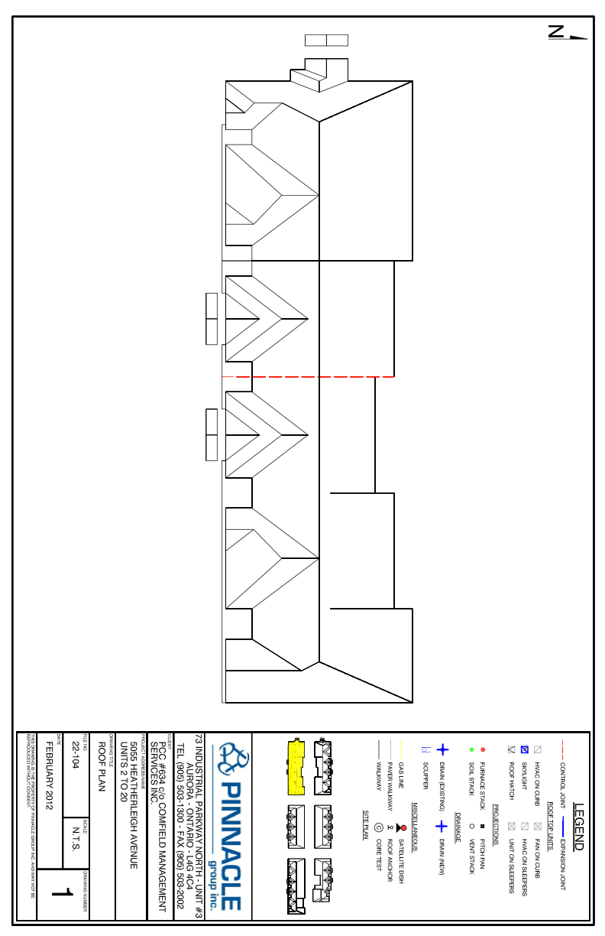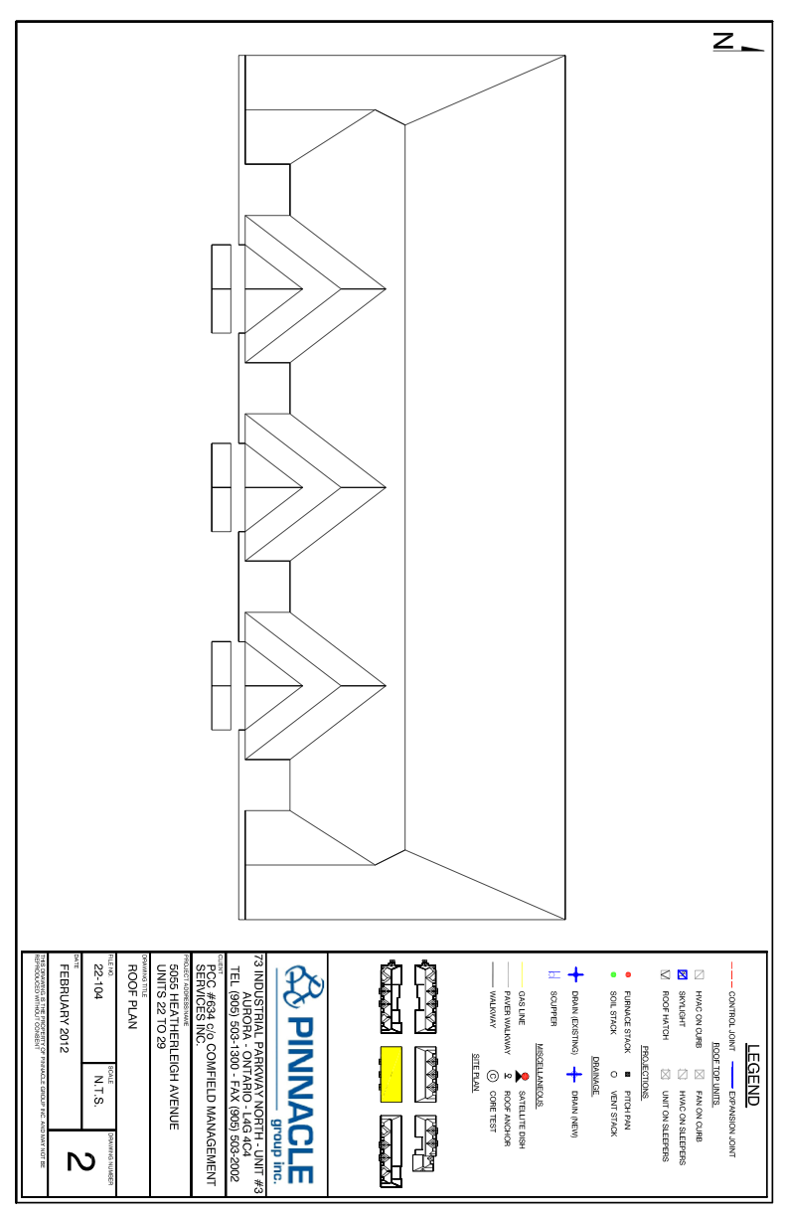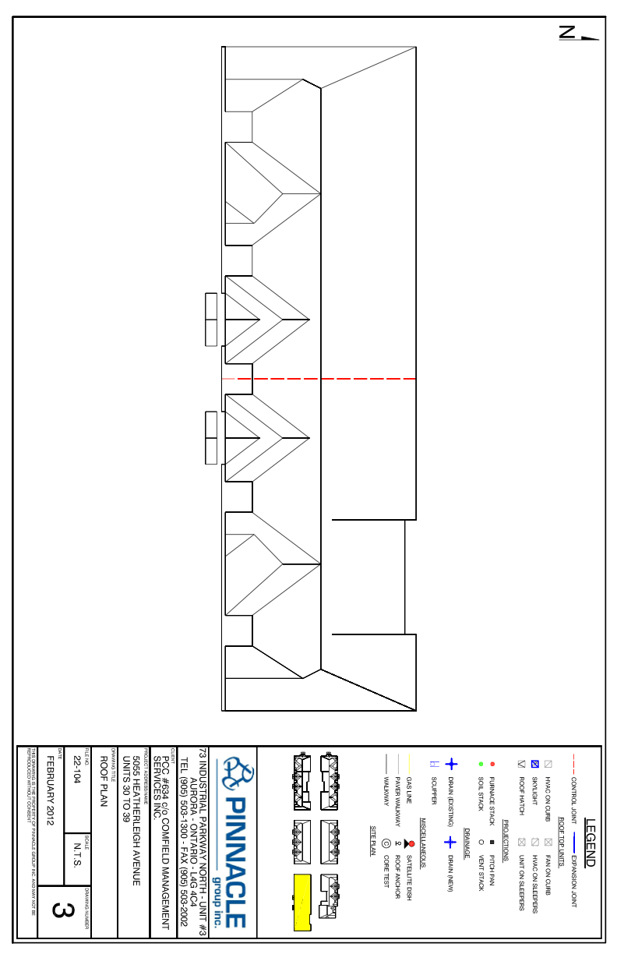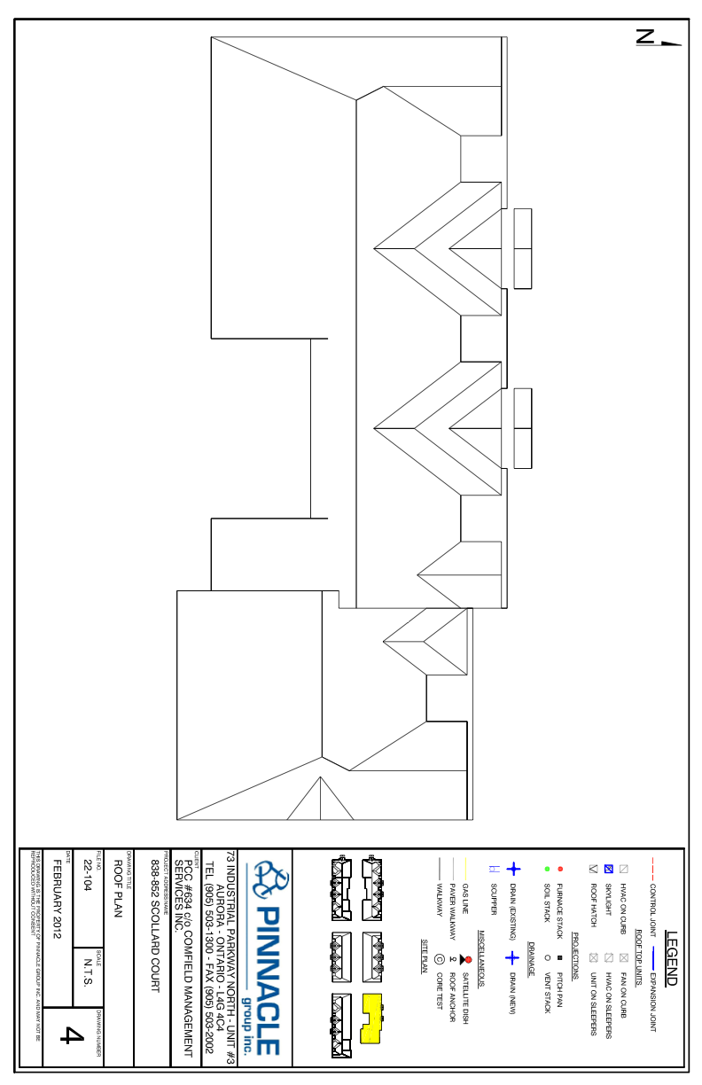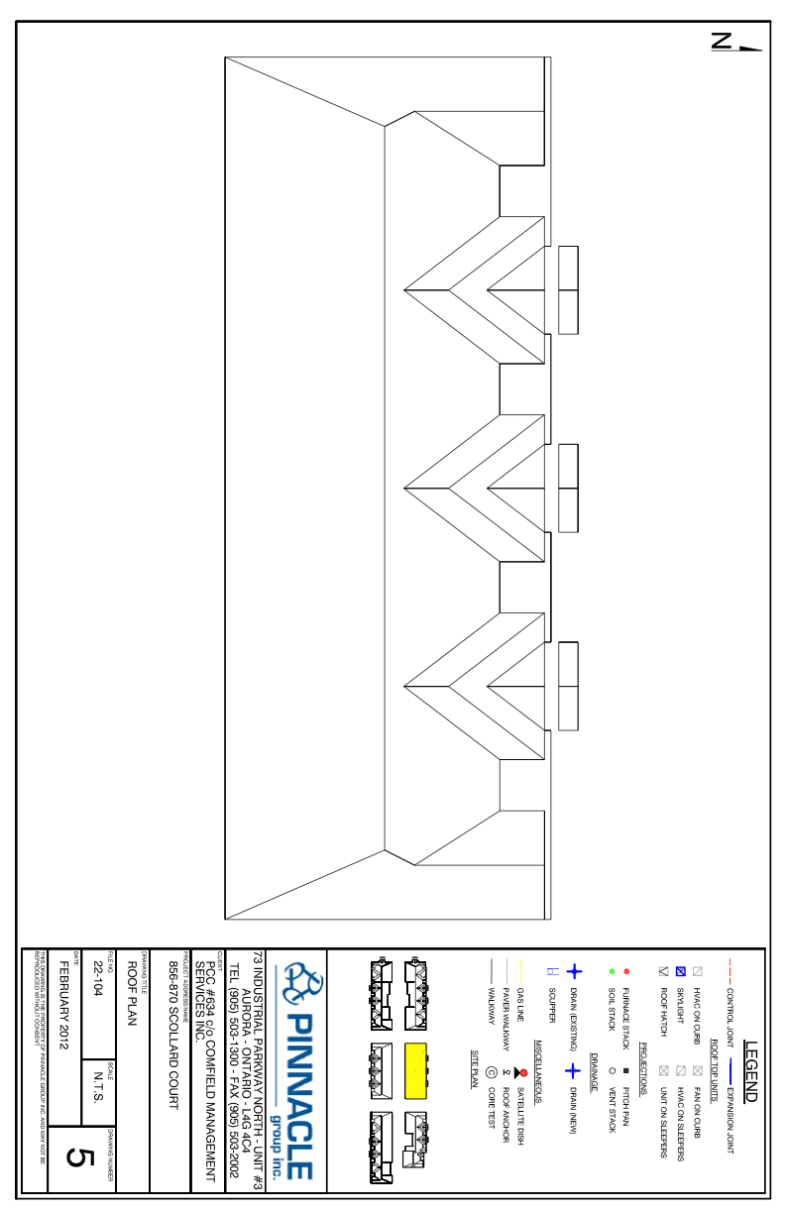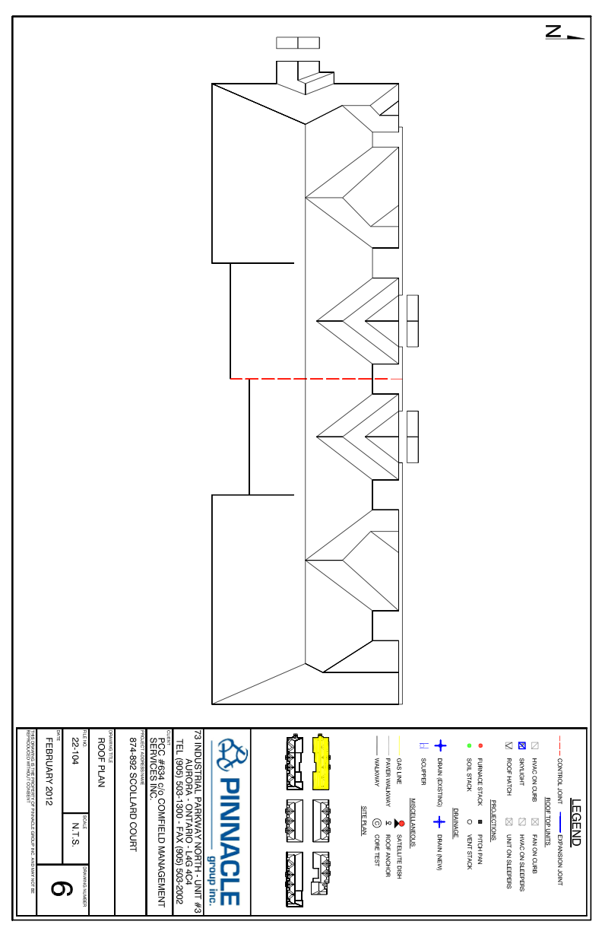
TENDERING INSTRUCTIONS TO BIDDERS
- All Tender spaces must be completed on the Tender Form. Errors, alterations, incomplete Tenders, unbalanced bids, or additional data, conditions, or pricing not requested in the Tender Documents may result in the Tender being declared "informal" and therefore invalid.
- Tenders shall be signed by an authorized officer of the Corporation under the Tenderer's Corporate Seal if the Tenderer is a Corporation, or by an authorized person under Seal if the Tenderer is a partnership or an individual.
- Submit the Tender in duplicate and sealed in an envelope for this purpose to: Harven Fung Property Manager PCC #634 c/o ComField Management Services Inc. 2171 Avenue Road, Suite 303 Toronto, Ontario M5M 4B4
- Any Tender received after the appointed time and date for Tender Closing will be returned unopened to the Bidder.
- All Tenders will be opened in private after the time and date of the Tender closing. No information concerning the results to the bids will be forthcoming until all Tenders have been reviewed and an award has been made.
TENDER FORMS
CLOSING TIME & DATE:
WORK DESCRIPTION:
PROJECT REFERENCE NUMBERS: Tender will be submitted to:
Friday, February 17th, 2012 at 10:00am
Harven Fung Property Manager PCC #634 c/o ComField Management Services Inc. 2171 Avenue Road, Suite 303 Toronto, Ontario M5M 4B4
This Tender is submitted by:
FIRM NAME:___________________________________________________ ADDRESS:_____________________________________________________ POSTAL CODE: TELEPHONE:__________________ FAX NUMBER:______________
We the undersigned _______________________________________________ of the City of ____________________________________________________ having examined the Tender Documents and site conditions, agree to supply all necessary labour, material, and services for the execution of the Work described above and in complete accord with the contract documents and procedural specifications for the stipulated sum of;

Tender Price $____________________
HST $____________________
UNIT PRICES Prices to include all applicable taxes, duties, and levies and force (excluding HST)
Item  Perimeter wood blocking (To Match Existing) | Unit  Per Linear Foot
Wood Deck Replacement (To Match Existing) | $ __________  Per Square Foot  $ __________
Roof Vents (Those installed over joists to be moved and reinstalled with unobstructed air flow. Repair original opening with plywood to match existing thickness) | Per Item  $ __________

SCHEDULE
Estimated Start Date _________ ________, 20_______
Estimated Completion Date _________ ________, 20_______
SUBCONTRACTORS TO BE USED ON THIS PROJECT
The roofing portion of this project can not be subcontracted and must be completed by the bidding Contractor’s own forces.
The insurance requirements of this contract shall extend to all Subcontractors and/or be carried under the prime Contractor’s insurance coverage.
It is our intention to employ the following Subcontractors in accordance with the Bid Documents. All portions of the Work other than those placed with the Subcontractors named will be executed by ourselves with our own workforce and are indicated below by the words "Own Forces". Prices listed below do NOT include HST.
WORK PRICE
Metal Fabrications _______________ $ __________
Rough Carpentry _______________ $ __________
Electrical _______________ $ __________
Mechanical _______________ $ __________
Plumbing _______________ $ __________

_______________________________________ name of bidder
_______________________________________ signature of authorized representative
_______________________________________ date
Special Notes
- This Tender shall remain valid and irrevocable for 60 days from the closing date.
- 100% Material, Labour, and Performance Bonds are required for this project and the cost for these bonds is to be carried in the Tender Price.
- This Tender Price includes compliance with all requirements set forth in the Tender package, and all the Work detailed in the specifications, drawings, and addenda up to and including Addendum Number .

Corporate Seal
__________________________________________ Name of Company
__________________________________________ Printed Name & Title of Company Official
__________________________________________ Signature of Company Official
__________________________________________ Printed Name & Title of Witness
__________________________________________ Signature of Witness
__________________________________________ Date

